Go Pro Rental Vehicle Platform - Smart Ride-Hailing and Rental Vehicle System
Saniya1, Nagabhiravanth K A 2, Ranjani Devi 3, Dr. Krishna Kumar P R4
1 Student, Dept. of Computer Science and Engineering, S E A College of Engineering and Technology, India.
2,3,4 Faculty, Dept. of Computer Science and Engineering,S E A College of Engineering and Technology, India.
TITLE : "Go Pro Rental Vehicle Platform: A Java-Based Smart Ride-Hailing and Rental Vehicle System"
Keywords : Ride-Hailing System, Rental Vehicle Platform, Java, Java Swing, Object-Oriented Programming, Driver Matching, Wallet Payment, Smart Transportation.

ABSTRACT
The growth of digital transportation services has increased the need for software platforms that simplify ride booking, improve fare transparency, and support better coordination between passengers and drivers. This paper presents the design and development of the Go Pro Rental Vehicle Platform, a Java-based ride-hailing and rental vehicle application developed as an academic project. The system provides user registration, login, ride booking, driver matching, fare calculation, simulated wallet payment, ride tracking, notifications, rating and review support, admin monitoring, and an SOS safety feature. The application is implemented using Java, Java Swing, object-oriented programming principles, and collection-based data handling. The system design is represented using data flow, entity relationship, use case, and class-based modeling concepts. Functional testing and project screenshots show that the proposed system successfully demonstrates the ride lifecycle from booking to payment completion. Although GPS tracking, live payment gateway, and cloud deployment are not implemented in the current version, the project provides a strong foundation for future intelligent transportation management systems.

1. INTRODUCTION
Transportation is an essential part of daily life, and digital platforms have transformed how users book vehicles and access travel services. Modern ride-hailing applications provide centralized booking, fare estimation, driver assignment, payment handling, and ride tracking. Traditional manual systems, however, still depend on street hailing, phone-based booking, or direct communication with local vehicle providers, which can result in delays, unclear fares, poor coordination, and limited safety records.
The Go Pro Rental Vehicle Platform is designed as a Java-based application that simulates the workflow of a smart ride-hailing and rental vehicle system. It allows users to create accounts, log in, book rides, select vehicle types, view fare estimates, complete wallet-based payment simulation, and track ride progress. Drivers can be assigned to ride requests, and administrators can monitor system activity. The project demonstrates practical software development using Java, Swing GUI design, and object-oriented programming.
The proposed work is useful for academic learning because the project combines graphical interface development, modular programming, driver matching logic, fare calculation, wallet operations, notification handling, and system design diagrams into one complete application workflow.

2. OBJECTIVES
1. To design a Java-based ride-hailing and rental vehicle platform for academic demonstration.
2. To provide user registration, login, ride booking, driver matching, and fare calculation features.
3. To simulate wallet payment, notifications, ride tracking, rating, and SOS safety support.
4. To apply object-oriented programming concepts through classes such as User, Driver, Vehicle, Ride, Payment, Wallet, and Notification.
5. To create a user-friendly Java Swing interface for passengers, drivers, and administrators.
6. To provide a modular structure that can be extended with database, GPS, cloud, and payment gateway support.

3. PROBLEM STATEMENT
Manual transportation and rental vehicle systems often lack a centralized digital workflow. Users may face difficulty finding vehicles, understanding fare details, communicating with drivers, and maintaining safe trip records. Local booking methods also make it difficult for administrators to manage users, drivers, rides, payments, and service history efficiently.
The problem addressed in this project is the need for a simple but complete software platform that can model the core functions of a ride-hailing and rental service. The system should support booking, allocation, payment simulation, tracking, and administrative monitoring within a maintainable Java application.

4. EXISTING SYSTEM
The existing transportation booking approach is largely manual or semi-digital. Users may need to search for vehicles physically, contact drivers by phone, or depend on local rental agencies. These systems do not maintain centralized booking records and often lack automated driver allocation, fare calculation, real-time status updates, and digital payment records.
The major disadvantages of the existing system include difficulty in finding available vehicles, lack of price transparency, safety issues, poor communication between users and drivers, time-consuming booking, and unreliable vehicle availability. These limitations create the need for a software-based platform that can manage ride requests, driver details, fare estimation, payment records, and notifications in a structured manner.

5. PROPOSED SYSTEM
The proposed Go Pro Rental Vehicle Platform provides a centralized ride-hailing and rental vehicle workflow. The application enables a user to register, log in, book a ride, choose a vehicle type, receive a fare estimate, and complete simulated payment. The driver matching process identifies an available driver and assigns the ride. The system also supports notifications, ride status updates, rating and review features, and an SOS safety option.
The platform is implemented in Java using a modular architecture. Java Swing is used for the graphical user interface, while Java classes represent real-world entities such as User, Driver, Vehicle, Ride, Payment, Wallet, and Notification. In-memory collections are used for academic demonstration, while the design remains SQL-ready for future database integration.

6. SYSTEM ARCHITECTURE
The platform follows a layered architecture consisting of user interface, business logic, and data handling components. The UI layer contains passenger, driver, and admin screens. The business logic layer performs registration, login, ride booking, driver matching, fare calculation, wallet payment, notifications, rating, and SOS processing. The data layer stores users, drivers, rides, vehicles, payments, and notifications using Java collections.
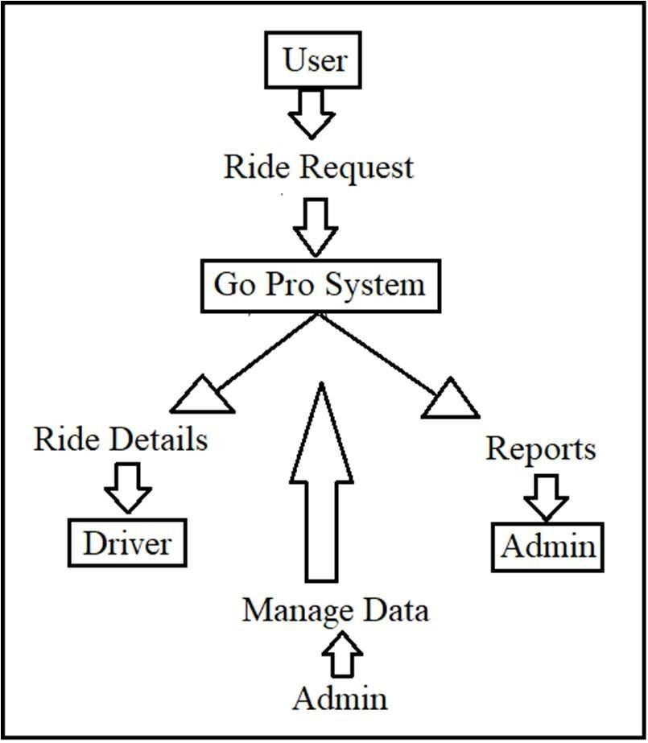
Fig. 1. DFD Level 0 context diagram
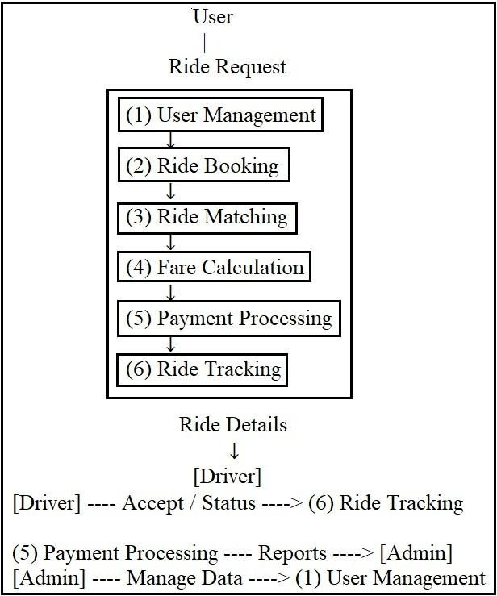
Fig. 2. DFD Level 1 processes
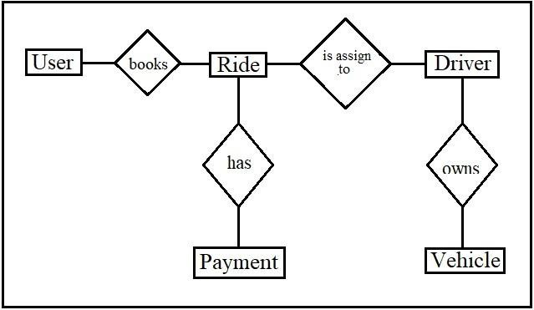
Fig. 3. Entity relationship model
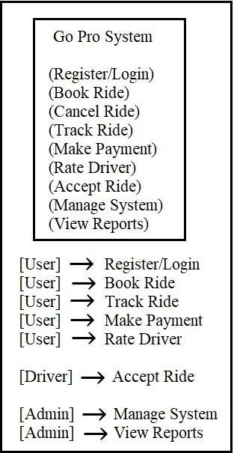
Fig. 4. Use case diagram
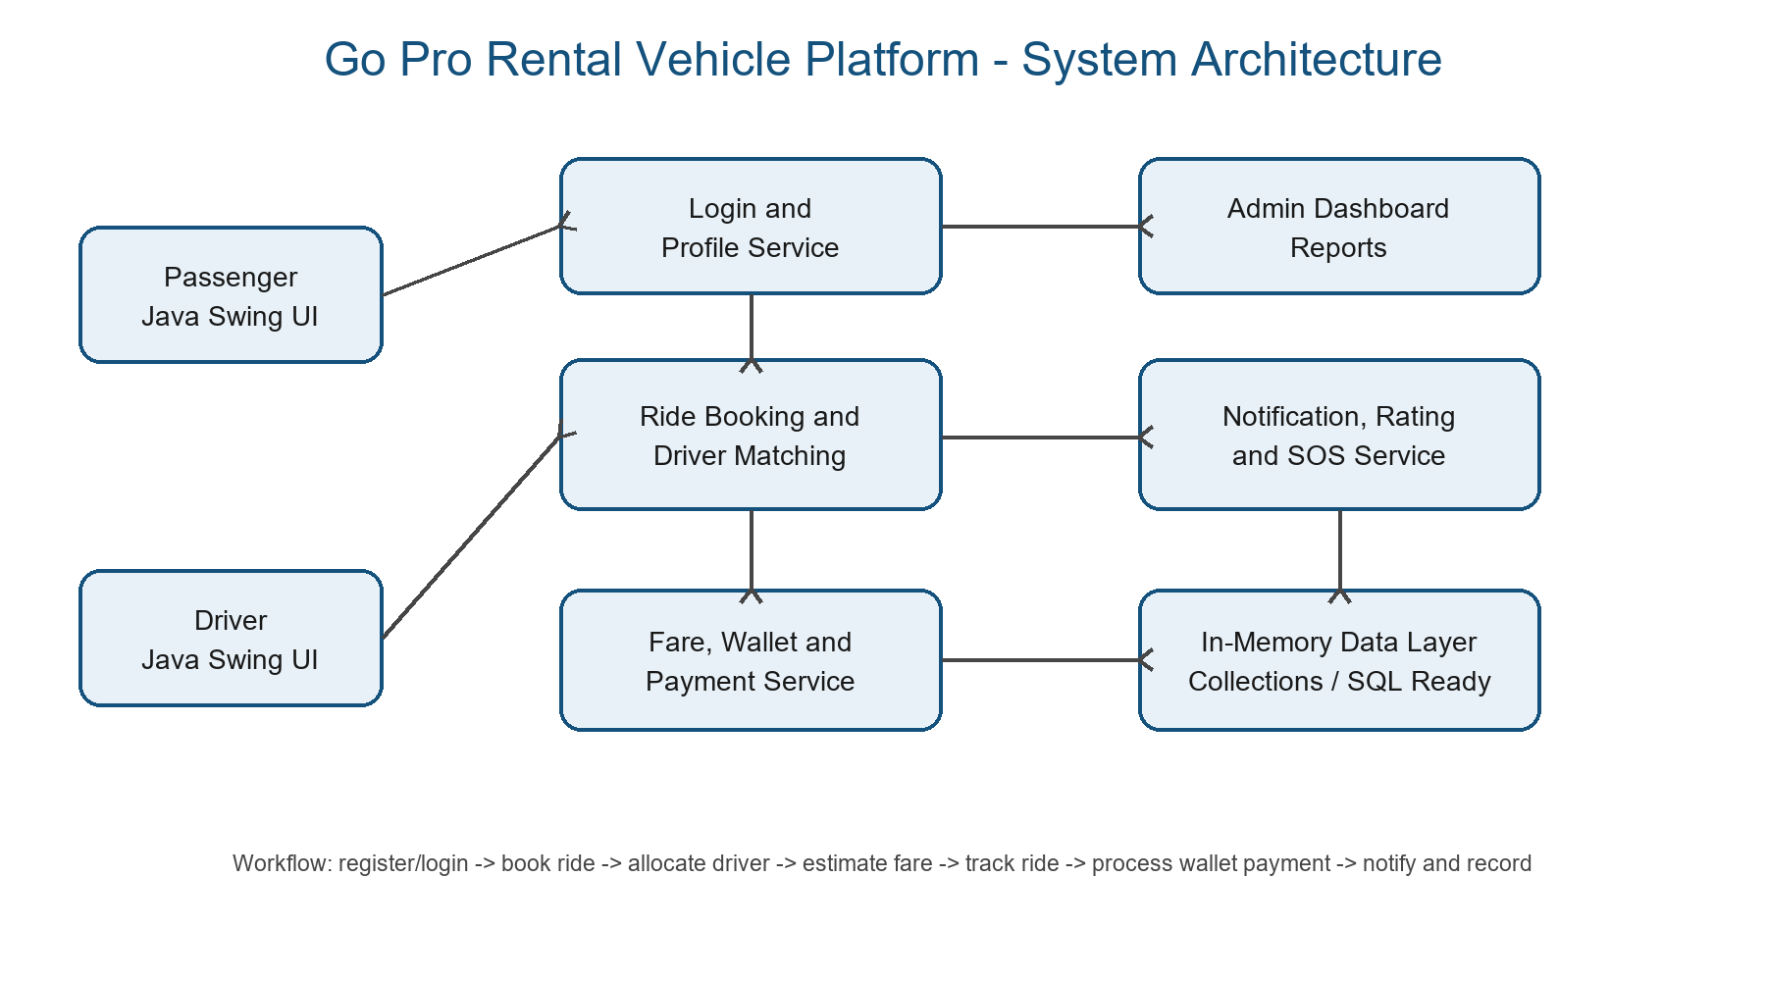
Fig. 5. Modular architecture

7. TECHNOLOGIES USED
Technology | Purpose
Java | Core programming language for application logic.
Java Swing | GUI forms, dashboards and dialogs.
OOP | Models User, Driver, Ride, Vehicle and Payment.
Collections | Temporary in-memory data storage.
SQL Concepts | Future persistent database layer.
IDE | Coding, debugging and running the application.
Table 1. Technologies used

8. METHODOLOGY
The development methodology follows object-oriented analysis and modular implementation. Requirements were first identified from the transportation workflow. Diagrams were prepared to model data flow, entity relationships, and user interactions. Java classes were developed for users, drivers, vehicles, rides, wallets, payments, and notifications. Finally, Swing-based screens were connected to the application logic and tested using sample ride scenarios.
1. Analyze the existing transportation and rental vehicle process.
2. Identify login, booking, matching, fare and payment requirements.
3. Design DFD, ER, use case and class-level models.
4. Implement Java classes using OOP concepts.
5. Develop graphical screens using Java Swing.
6. Test the ride lifecycle from booking to payment completion.
The driver matching logic selects an available driver based on the ride request and requested vehicle category. Once the driver is assigned, the ride status changes from requested to confirmed. The fare calculation uses a transparent model based on base fare, distance charge, and vehicle type multiplier.

9. IMPLEMENTATION
The system is implemented using Java and Java Swing. The application includes separate screens for public landing information, account creation, login, ride booking, and ride confirmation. The interface contains vehicle options, service features, and booking controls to make the prototype user-friendly.
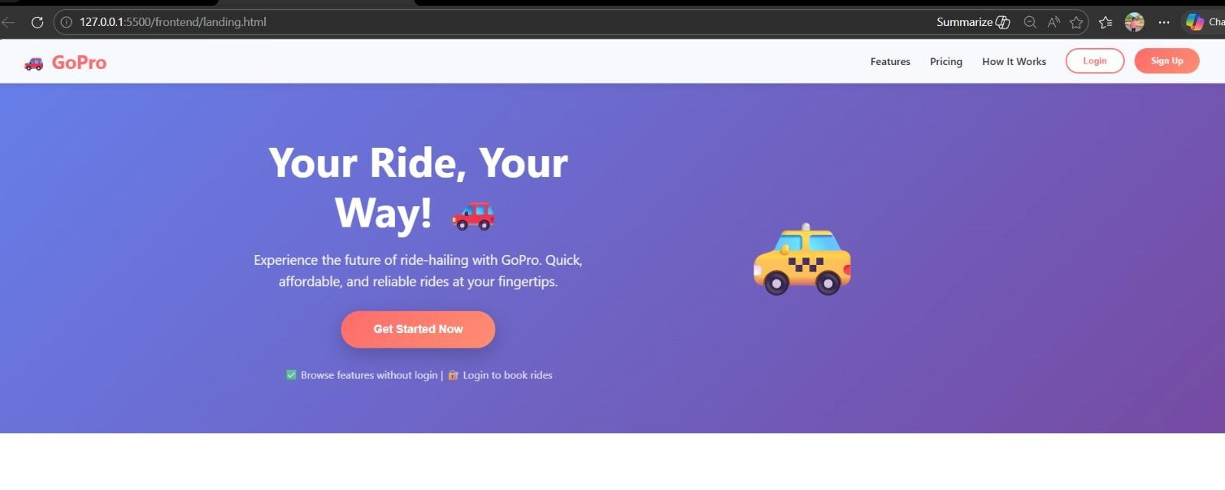
Fig. 6. Home page
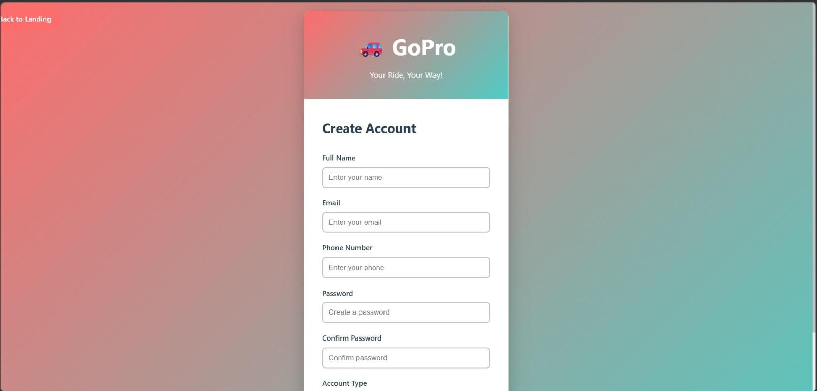
Fig. 7. Account creation screen
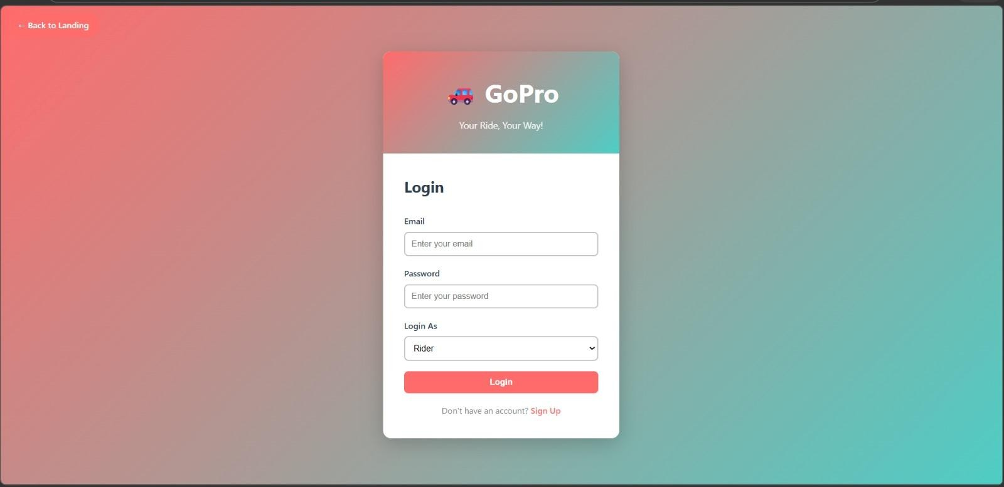
Fig. 8. Login screen
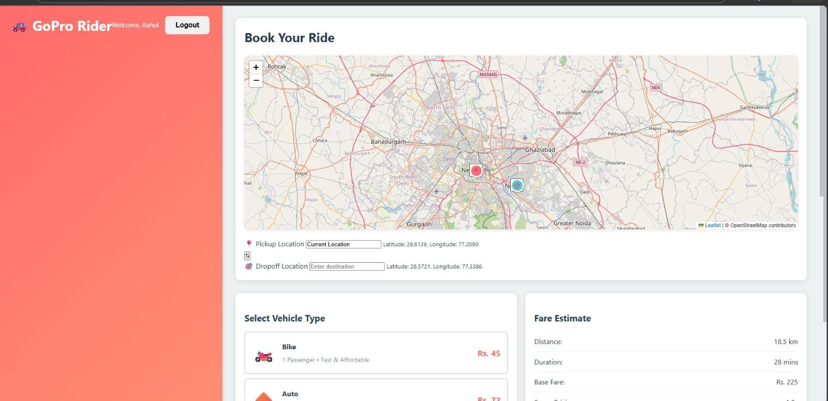
Fig. 9. Ride booking screen
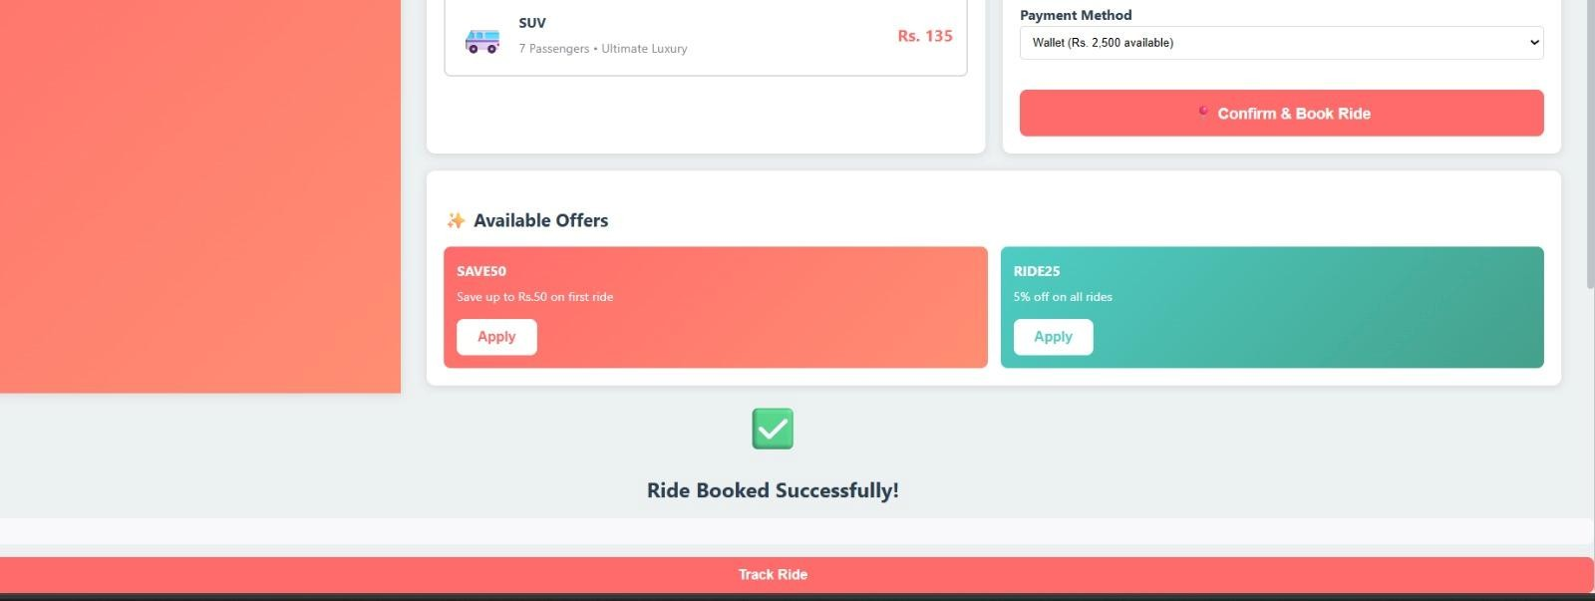
Fig. 10. Booking output
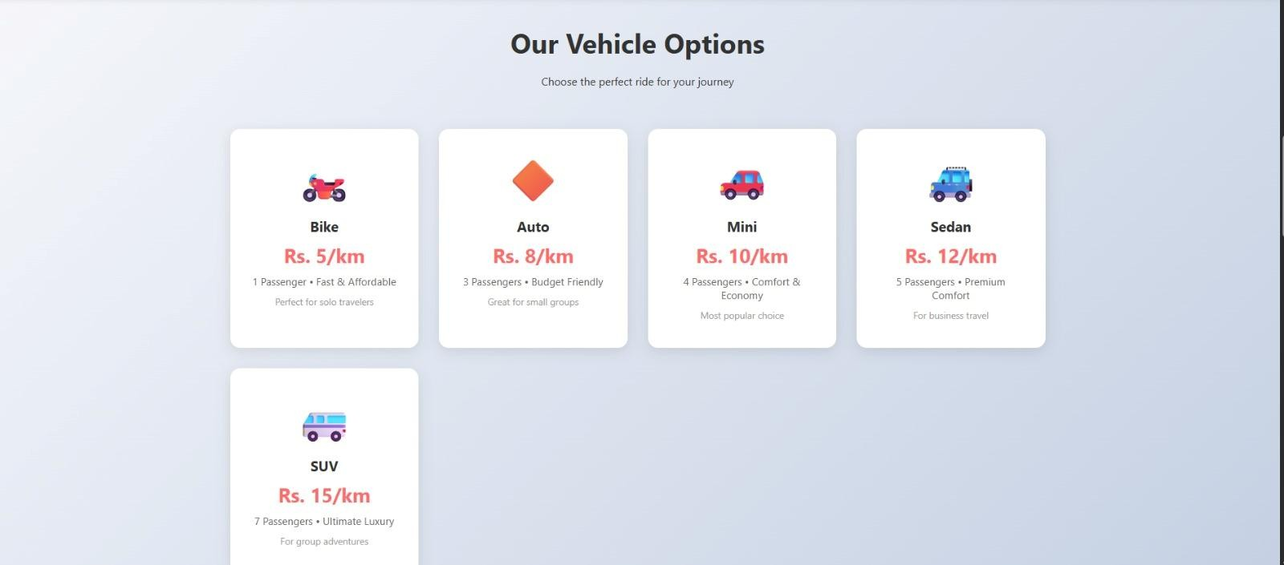
Fig. 11. Vehicle options

10. RESULTS
The project output demonstrates the major screens and functions of the Go Pro Rental Vehicle Platform. The user can access the home page, create an account, log in, book a ride, select ride details, and view booking confirmation. These outputs show that the system can support the basic ride-hailing workflow in a local Java-based environment.
Test | Scenario | Output | Result
Registration | Valid details | Account created | Pass
Login | Valid credentials | Dashboard opens | Pass
Booking | Pickup/drop entered | Ride created | Pass
Vehicle | Type selected | Fare adjusted | Pass
Matching | Driver available | Driver assigned | Pass
Payment | Balance available | Success | Pass
Table 2. Functional testing summary
The application improves booking organization and fare visibility compared to manual transportation methods. It also demonstrates practical use of object-oriented programming, modular architecture, GUI development, and event-driven programming.

11. FUTURE ENHANCEMENTS
- Real-time GPS and map API integration.
- SQL database connectivity.
- Cloud deployment for remote access.
- Mobile application support.
- UPI or card payment gateway integration.
- AI-based driver allocation.
- OTP login and stronger security.
- Invoice generation and analytics dashboard.

12. CONCLUSION
The Go Pro Rental Vehicle Platform successfully demonstrates a Java-based ride-hailing and rental vehicle management system. The project includes registration, login, ride booking, driver matching, fare calculation, wallet payment simulation, notifications, ride tracking, rating, SOS support, and admin monitoring. The use of Java, Swing, and object-oriented design makes the project suitable for academic learning and future extension.
Although it is not a fully deployed commercial system, it provides a strong foundation for understanding smart transportation software development. With future enhancements such as GPS integration, database support, cloud deployment, and secure online payment, the system can be expanded into a more practical transportation management application.

13. REFERENCES
[1] I. Sommerville, Software Engineering, 10th ed. Boston, MA, USA: Pearson, 2016.
[2] R. S. Pressman and B. R. Maxim, Software Engineering: A Practitioner's Approach, 8th ed. New York, NY, USA: McGraw-Hill Education, 2014.
[3] H. Schildt, Java: The Complete Reference, 11th ed. New York, NY, USA: McGraw-Hill Education, 2018.
[4] C. S. Horstmann, Core Java Volume I: Fundamentals, 11th ed. Boston, MA, USA: Pearson, 2018.
[5] E. Gamma, R. Helm, R. Johnson, and J. Vlissides, Design Patterns: Elements of Reusable Object-Oriented Software. Boston, MA, USA: Addison-Wesley, 1994.
[6] J. Alonso-Mora, S. Samaranayake, A. Wallar, E. Frazzoli, and D. Rus, "On-demand high-capacity ride-sharing via dynamic trip-vehicle assignment," Proceedings of the National Academy of Sciences, vol. 114, no. 3, pp. 462-467, 2017, doi: 10.1073/pnas.1611675114.
[7] E. Ozkan and A. R. Ward, "Dynamic Matching for Real-Time Ride Sharing," Stochastic Systems, vol. 10, no. 1, pp. 29-70, 2020, doi: 10.1287/stsy.2019.0037.
[8] N. Agatz, A. Erera, M. Savelsbergh, and X. Wang, "Optimization for dynamic ride-sharing: A review," European Journal of Operational Research, vol. 223, no. 2, pp. 295-303, 2012, doi: 10.1016/j.ejor.2012.05.028.
[9] T. Cokyasar, F. de Souza, J. Auld, and O. Verbas, "Dynamic Ride-Matching for Large-Scale Transportation Systems," Transportation Research Record, vol. 2676, no. 3, pp. 101-112, 2022, doi: 10.1177/03611981211049422.
[10] NITI Aayog, "Transforming Mobility: A Perspective," Government of India, 2018.

