AI-Based Network Intrusion Detection System Using Machine Learning for Enterprise Networks
[Author Name(s) — to be inserted]
[Department / Institution, City, Country — to be inserted]
[Corresponding author email — to be inserted]
Abstract
Enterprise networks face an increasingly sophisticated and high-volume threat landscape that traditional signature-based Intrusion Detection Systems (IDS) struggle to address, particularly against novel and zero-day attacks. This paper presents a comparative study and design framework for an AI-based Network Intrusion Detection System (NIDS) that applies supervised machine learning to classify network traffic as benign or malicious, and to further categorize attacks into Denial-of-Service (DoS), Probe, Remote-to-Local (R2L), and User-to-Root (U2R) classes. Eight machine learning algorithms — Random Forest, Gradient Boosting, Decision Tree, Multi-Layer Perceptron, Support Vector Machine, Naive Bayes, K-Nearest Neighbors, and Logistic Regression — are trained and evaluated on the benchmark NSL-KDD dataset using standard preprocessing, feature scaling, and stratified train/test partitions. Experimental results show that ensemble tree-based methods provide the strongest overall balance of accuracy and robustness, with Gradient Boosting achieving 80.6% binary classification accuracy and Random Forest achieving the highest area-under-curve (AUC) of 0.970. Feature importance analysis identifies source/destination byte counts, service type, and login status as the most discriminative traffic attributes. A modular enterprise deployment architecture integrating flow capture, preprocessing, ML inference, SIEM alerting, and continuous retraining is proposed. The results, limitations regarding minority attack classes such as R2L and U2R, and directions for future work using deep learning and hybrid ensembles are discussed.
Keywords: Network Intrusion Detection, Machine Learning, Enterprise Network Security, NSL-KDD, Random Forest, Anomaly Detection, Cybersecurity, SIEM

1. Introduction
Enterprise networks form the digital backbone of modern organizations, connecting employees, applications, cloud services, and critical infrastructure. As enterprises expand their digital footprint through cloud adoption, remote work, and Internet of Things (IoT) deployments, the network attack surface has grown correspondingly, exposing organizations to a wide spectrum of threats ranging from reconnaissance scans and denial-of-service floods to privilege escalation and data exfiltration.
Traditional Intrusion Detection Systems (IDS) rely largely on signature matching or manually crafted rules to identify known attack patterns. While effective against previously catalogued threats, such systems are inherently reactive: they cannot detect novel or zero-day attacks whose signatures have not yet been defined, and they typically require constant manual rule maintenance that struggles to keep pace with the volume and diversity of modern network traffic. This limitation has motivated a shift toward anomaly-based and machine-learning (ML) driven intrusion detection, which learns statistical or behavioral patterns of normal and malicious traffic directly from data and can generalize to previously unseen attack variants.
Machine learning offers several advantages for enterprise-scale intrusion detection: the ability to process high-dimensional flow and packet-level features, the capacity to learn nonlinear decision boundaries between benign and malicious behavior, and the potential for continuous retraining as network conditions and threat patterns evolve. However, deploying ML-based NIDS in production enterprise environments introduces practical challenges, including class imbalance between benign and attack traffic (and between attack subtypes), the computational cost of real-time inference at line rate, the need to minimize false positives to avoid alert fatigue in security operations centers (SOCs), and the risk of model degradation as traffic patterns drift over time.
This paper makes the following contributions:
- A systematic comparison of eight supervised machine learning algorithms for binary (normal/attack) and multiclass (DoS/Probe/R2L/U2R) network intrusion detection on the NSL-KDD benchmark dataset.
- A feature importance analysis identifying which network traffic attributes are most predictive of malicious activity, informing lightweight feature engineering for real-time deployment.
- A modular reference architecture for integrating ML-based detection into enterprise network security operations, including SIEM alerting and continuous model retraining.
- A discussion of the practical limitations of current benchmark-driven ML-NIDS research, particularly regarding rare attack classes and generalization to real enterprise traffic.
The remainder of this paper is organized as follows. Section 2 reviews related work in ML-based intrusion detection. Section 3 describes the proposed system architecture and methodology, including the dataset, preprocessing pipeline, and algorithms employed. Section 4 details the experimental setup. Section 5 presents and discusses the results. Section 6 discusses enterprise deployment considerations and limitations. Section 7 concludes the paper and outlines future work.

2. Related Work
The NSL-KDD dataset used in this study was introduced by Tavallaee et al. [1] to address well-documented statistical flaws in the original KDD Cup 1999 dataset, including a large proportion of redundant records that biased classifier evaluation toward frequent attack types. By removing duplicate records and rebalancing the difficulty distribution, NSL-KDD has become a standard, widely reproducible benchmark for comparing intrusion detection algorithms.
Solanki et al. [2] surveyed a range of machine learning and Support Vector Machine (SVM)–based approaches applied to NSL-KDD and observed that hybrid combinations of SVM with other classifiers tend to outperform single-algorithm approaches, motivating comparative and ensemble-based studies such as the one presented here.
AlQahtani et al. [3] proposed a customized Artificial Neural Network (ANN) architecture implemented in Keras and reported a peak detection accuracy of approximately 97.5% on NSL-KDD, demonstrating the potential of carefully tuned deep architectures, although such results are sensitive to the specific train/test split and evaluation protocol used.
Deep learning approaches have also been explored extensively. A convolutional neural network and long short-term memory (CNN-LSTM) hybrid model [7] was proposed to capture both spatial and temporal correlations in network flow features, illustrating a trend toward representation-learning approaches that reduce reliance on manual feature engineering. Similarly, a hybrid Self-Organizing Map (SOM) framework [6] combined unsupervised dimensionality reduction with supervised classification to improve multiclass attack categorization, an approach conceptually related to the feature-importance-guided pipeline used in this paper.
Beyond enterprise LAN traffic, machine learning-based detection has also been applied to specialized environments. Hafeez et al. [5] developed IoT-KEEPER, an online traffic analysis system for detecting malicious activity at the network edge in IoT deployments, while related work has applied artificial neural networks to IoT-focused datasets such as UNSW-NB15 [4]. These studies highlight those detection pipelines must often be adapted to the traffic characteristics of the deployment environment, whether enterprise core networks, IoT edge segments, or cloud infrastructure.
Comparative benchmarking studies using accessible ML toolkits, such as an evaluation of multiple KNIME classifiers on NSL-KDD [9], consistently report that classifier performance degrades substantially when test data contains attack types not present during training — a generalization problem that also affects the R2L and U2R classes in the present study. Adversarial robustness has emerged as a further concern: Warzyński and Kołaczek [8] showed that ML-based IDS models, including neural networks, can be vulnerable to crafted adversarial perturbations, underscoring the need for robustness testing before production deployment. A broader review by Mishra [10] similarly concludes that while ML-based IDS consistently outperform static signature-based systems on benchmark accuracy, real-world deployment requires attention to class imbalance, concept drift, and integration with existing security operations workflows — themes that directly motivate the enterprise deployment architecture proposed in Section 3 of this paper.
Table 1 summarizes representative NSL-KDD-based studies alongside the results obtained in this work.
Table 1. Representative Related Work on NSL-KDD-Based Intrusion Detection
Study | Dataset | Method | Reported Accuracy
Solanki et al. (2020) [2] | NSL-KDD | Survey: SVM, hybrid ML | Varies by technique
AlQahtani et al. [3] | NSL-KDD | Customized ANN (Keras) | 97.5%
CSAI'18 CNN-LSTM study [7] | NSL-KDD | Hybrid CNN + LSTM | Not directly comparable (DL)
Hybrid SOM study [6] | NSL-KDD | Self-Organizing Map + supervised | Multiclass, improved over baseline
This work | NSL-KDD | 8 classical ML models compared | 80.6% (Gradient Boosting, binary)
A common thread across this literature is that reported accuracy figures vary widely (70%–98%) depending on the classification task (binary vs. multiclass), preprocessing choices, and whether the more difficult KDDTest+ partition (which includes attack subtypes absent from training) is used, as it is in this study. This variability motivates the standardized, multi-algorithm comparison presented in Section 5, rather than relying on a single reported figure from prior work.

3. Proposed System Architecture and Methodology

3.1 System Overview
The proposed AI-based NIDS follows a modular pipeline designed for integration into an enterprise Security Operations Center (SOC), as illustrated in Figure 1. Raw traffic is captured from routers, switches, or network taps and converted into flow-level records. These records undergo preprocessing (categorical encoding, missing-value handling, and feature scaling) before being passed through a feature selection stage that retains the most discriminative attributes. The resulting feature vectors are classified by an ensemble of candidate ML models; the highest-confidence classifier output triggers the Alert and Response Module, which forwards structured alerts to a SIEM or SOC dashboard for triage. A continuous retraining feedback loop incorporates analyst-labeled data to mitigate concept drift over time.
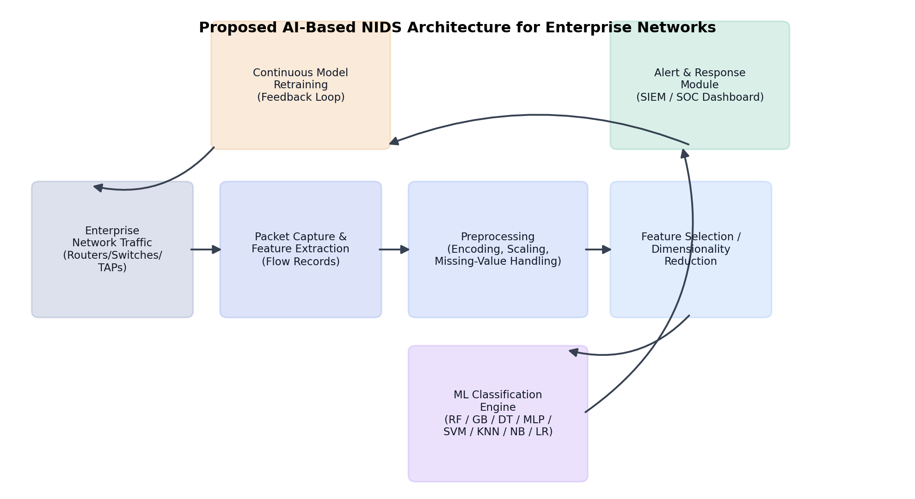
Figure 1. Proposed AI-based NIDS architecture for enterprise networks.

3.2 Dataset Description
This study uses the NSL-KDD benchmark dataset [1], a refined version of the KDD Cup 1999 dataset that removes redundant records and provides a more balanced difficulty distribution for evaluating intrusion detection classifiers. The dataset contains 41 features per connection record spanning basic connection attributes (e.g., duration, protocol type, service, flag), content features (e.g., number of failed logins, root shell access), and traffic-based statistical features computed over two-second windows (e.g., connection count, error rates, same/different service rates). Each record is labeled as either normal traffic or one of 22 attack types in the training partition (KDDTrain+), which are further grouped into four high-level attack categories.
The four attack categories used for multiclass evaluation are:
- DoS (Denial of Service): floods or resource-exhaustion attacks such as neptune, smurf, and back.
- Probe: surveillance and port-scanning activity such as ipsweep, portsweep, and nmap.
- R2L (Remote to Local): unauthorized remote access attempts such as guess_passwd and ftp_write.
- U2R (User to Root): privilege escalation attacks such as buffer_overflow and rootkit.
The training partition (KDDTrain+) contains 125,973 records (67,343 normal, 58,630 attack), and the independent test partition (KDDTest+) contains 22,544 records (9,711 normal, 12,833 attack). Critically, KDDTest+ includes attack subtypes that do not appear in KDDTrain+, which makes it a substantially more realistic and challenging evaluation than a random split of the same distribution, and better approximates the zero-day detection challenge faced in production enterprise environments.

3.3 Data Preprocessing
Three categorical features — protocol_type, service, and flag — were converted to numerical form using label encoding fit jointly across the training and test partitions to ensure consistent category mappings. All 41 numerical features were then standardized using z-score normalization (zero mean, unit variance) fitted on the training set and applied to both partitions, preventing information leakage from the test set while ensuring that features with large numeric ranges (e.g., byte counts) do not dominate distance-based classifiers such as KNN and SVM. Labels were binarized (normal vs. attack) for the primary comparison and separately mapped to the five-class scheme (Normal, DoS, Probe, R2L, U2R) for multiclass evaluation.

3.4 Machine Learning Algorithms
Eight supervised classifiers, representing a broad cross-section of algorithm families commonly used in NIDS research, were trained and evaluated:
Random Forest: An ensemble of decision trees trained on bootstrap-sampled data with random feature subsets, aggregating predictions via majority voting to reduce overfitting and variance.
Gradient Boosting: A sequential ensemble that iteratively fits new trees to the residual errors of prior trees, often achieving strong predictive accuracy at the cost of longer training time.
Decision Tree: A single interpretable tree that recursively partitions the feature space using information-gain criteria; fast to train but prone to overfitting.
Multi-Layer Perceptron (MLP): A feed-forward neural network with two hidden layers (64 and 32 units) capable of learning nonlinear decision boundaries.
Support Vector Machine (SVM): A maximum-margin classifier using a Radial Basis Function (RBF) kernel to separate classes in a transformed feature space.
Naive Bayes: A probabilistic classifier assuming conditional feature independence given the class, offering very fast training and inference.
K-Nearest Neighbors (KNN): A non-parametric, instance-based classifier that assigns the majority label among the k nearest training samples in feature space (k = 5).
Logistic Regression: A linear probabilistic classifier serving as a baseline against which nonlinear models are compared.
For the binary classification task, all models were trained on the full 125,973-record training partition, with the exception of the SVM, whose training set was reduced to a stratified 15,000-sample subset to keep training time within a practical range given the computational cost of RBF-kernel SVMs at scale; this is a common practical trade-off in enterprise ML pipelines that is reported transparently in Section 5. For multiclass classification, a Random Forest with balanced class weighting was used to partially mitigate the severe class imbalance affecting the R2L and U2R categories.

3.5 Evaluation Metrics
Model performance was assessed using accuracy, precision, recall, F1-score, and Area Under the ROC Curve (AUC), computed with respect to the independent KDDTest+ partition. For enterprise intrusion detection, recall on the attack class (the true positive rate for malicious traffic) and precision on the normal class (which governs the false-positive/alert-fatigue rate) are of particular operational importance, and are reported separately in addition to aggregate accuracy.

4. Experimental Setup
All experiments were implemented in Python 3 using scikit-learn for model training and evaluation, pandas/NumPy for data handling, and Matplotlib/Seaborn for visualization. Models were trained on the standardized KDDTrain+ partition and evaluated on the untouched KDDTest+ partition, ensuring that reported metrics reflect generalization to traffic patterns — including previously unseen attack subtypes — not present during training. Default or lightly tuned hyperparameters were used for each algorithm (e.g., 150–200 trees for ensemble methods, RBF kernel for SVM, two hidden layers for the MLP) to provide a fair, reproducible baseline comparison rather than an exhaustively tuned result for any single model. Training and inference times were recorded on the same compute environment for all models to allow a consistent efficiency comparison.

5. Results and Discussion

5.1 Binary Classification: Normal vs. Attack
Table 2 reports binary classification performance (normal vs. attack) for all eight models on the KDDTest+ partition. Gradient Boosting achieved the highest overall accuracy (80.64%) and F1-score on the attack class (80.05%), while Random Forest achieved the highest AUC (0.970), indicating the strongest ranking ability between classes across all decision thresholds. All models achieved high precision on the attack class (91–97%), meaning that when an alert is raised, it is highly likely to correspond to genuine malicious traffic — an important property for minimizing analyst alert fatigue in a SOC setting. However, recall on the attack class was comparatively lower (60–68%) across all models, reflecting the difficulty of detecting attack subtypes in KDDTest+ that were not present during training.
Table 2. Binary Classification Performance on KDDTest+ (Attack-Class Metrics for Precision/Recall/F1)
Model | Accuracy | Precision | Recall | F1-Score | AUC-ROC | Train Time (s)
Random Forest | 77.19% | 96.65% | 62.08% | 75.60% | 0.970 | 13.79
Gradient Boosting | 80.64% | 96.81% | 68.25% | 80.05% | 0.962 | 23.04
Decision Tree | 79.44% | 96.71% | 66.14% | 78.56% | 0.816 | 0.88
MLP (Neural Net) | 78.06% | 96.73% | 63.60% | 76.74% | 0.911 | 55.62
SVM (RBF) | 77.75% | 97.26% | 62.67% | 76.23% | 0.917 | 7.54*
Naive Bayes | 77.14% | 91.14% | 66.29% | 76.75% | 0.856 | 0.43
K-Nearest Neighbors | 76.76% | 97.12% | 60.98% | 74.92% | 0.823 | 0.05
Logistic Regression | 75.39% | 92.53% | 61.76% | 74.08% | 0.871 | 2.59
*SVM training time is reported on a stratified 15,000-record subsample (see Section 3.4); inference (prediction) time for SVM and KNN was markedly higher than for tree-based models, reflecting the cost of kernel and distance computations at prediction time — a relevant consideration for real-time enterprise deployment.

5.2 ROC Curve Analysis
Figure 2 compares ROC curves for the three top-performing probabilistic models. Random Forest and Gradient Boosting show similar, strongly convex curves well above the diagonal, confirming their superior ranking ability across decision thresholds, while Logistic Regression, as a linear baseline, shows a comparatively less favorable trade-off between true and false positive rates.
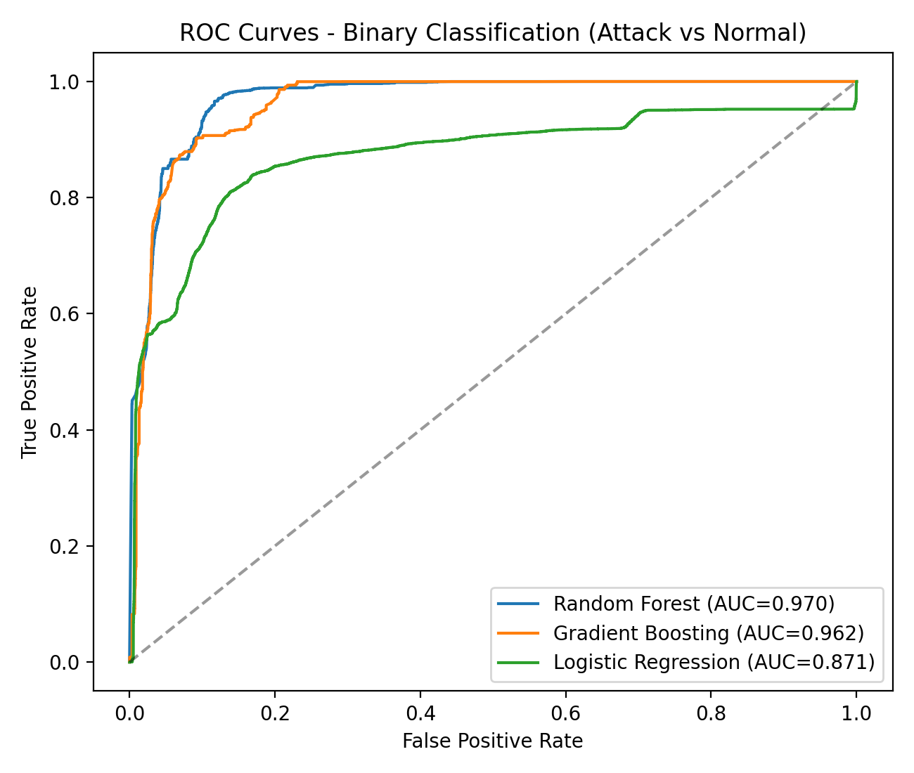
Figure 2. ROC curves for Random Forest, Gradient Boosting, and Logistic Regression (binary classification).

5.3 Multiclass Attack Categorization
Table 3 presents per-class precision, recall, and F1-score for the five-class (Normal, DoS, Probe, R2L, U2R) Random Forest classifier, and Figure 3 shows the corresponding confusion matrix. The model performs well on Normal and DoS traffic (F1 = 0.77 and 0.86 respectively), reflecting their large representation in the training data. Probe detection is moderate (F1 = 0.70). Performance on R2L (F1 = 0.00) and U2R (F1 = 0.06) is poor, which is consistent with prior literature and is attributable to two compounding factors: severe class imbalance (R2L and U2R together represent under 1% of training records) and the presence of R2L/U2R attack subtypes in KDDTest+ that never appear in KDDTrain+, making them effectively a zero-day detection problem for a purely supervised model.
Table 3. Multiclass Classification Report (Random Forest, Balanced Class Weighting)
Class | Precision | Recall | F1-Score | Support
Normal | 0.64 | 0.97 | 0.77 | 9711
DoS | 0.96 | 0.77 | 0.86 | 7460
Probe | 0.86 | 0.59 | 0.70 | 2421
R2L | 0.57 | 0.00 | 0.00 | 2885
U2R | 0.50 | 0.03 | 0.06 | 67
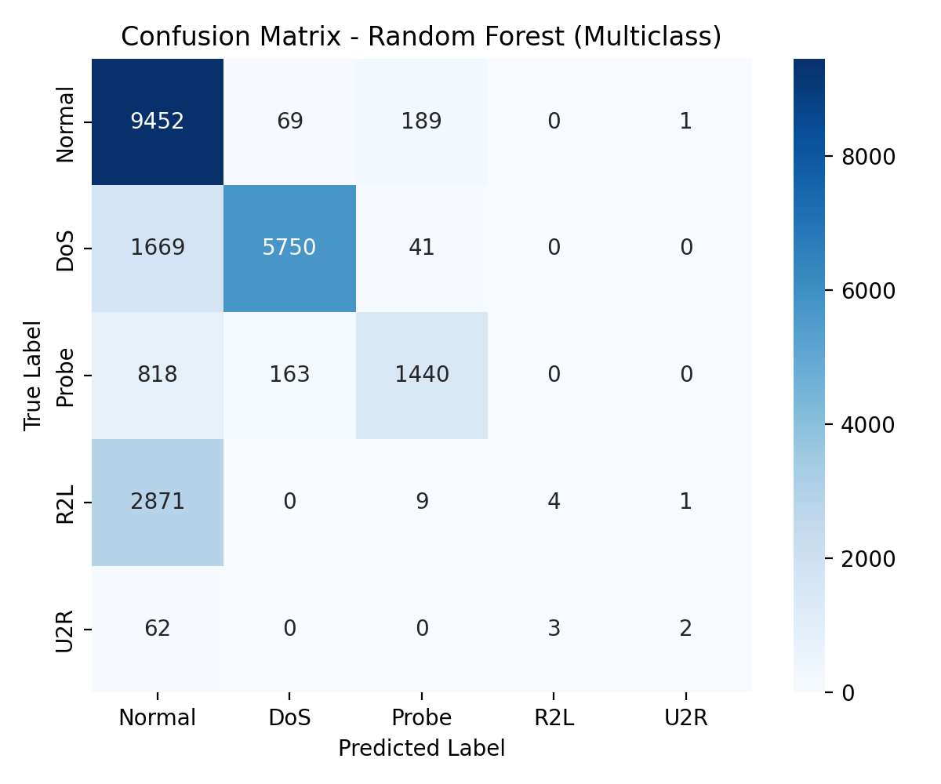
Figure 3. Confusion matrix for multiclass attack categorization (Random Forest).

5.4 Feature Importance Analysis
Figure 4 and Table 4 report the ten most important features identified by the Random Forest multiclass model using Gini importance. Traffic volume features (src_bytes, dst_bytes), the destination service, and login success status emerged as the most discriminative attributes, followed by host-level connection statistics such as dst_host_srv_count and dst_host_serror_rate. This finding has direct practical value for enterprise deployment: a lightweight NIDS could achieve much of its discriminative power using a reduced feature set drawn primarily from basic flow statistics (byte counts, service, login status) and host-based error/connection rates, without requiring deep packet inspection of payload content — reducing both computational overhead and privacy exposure.
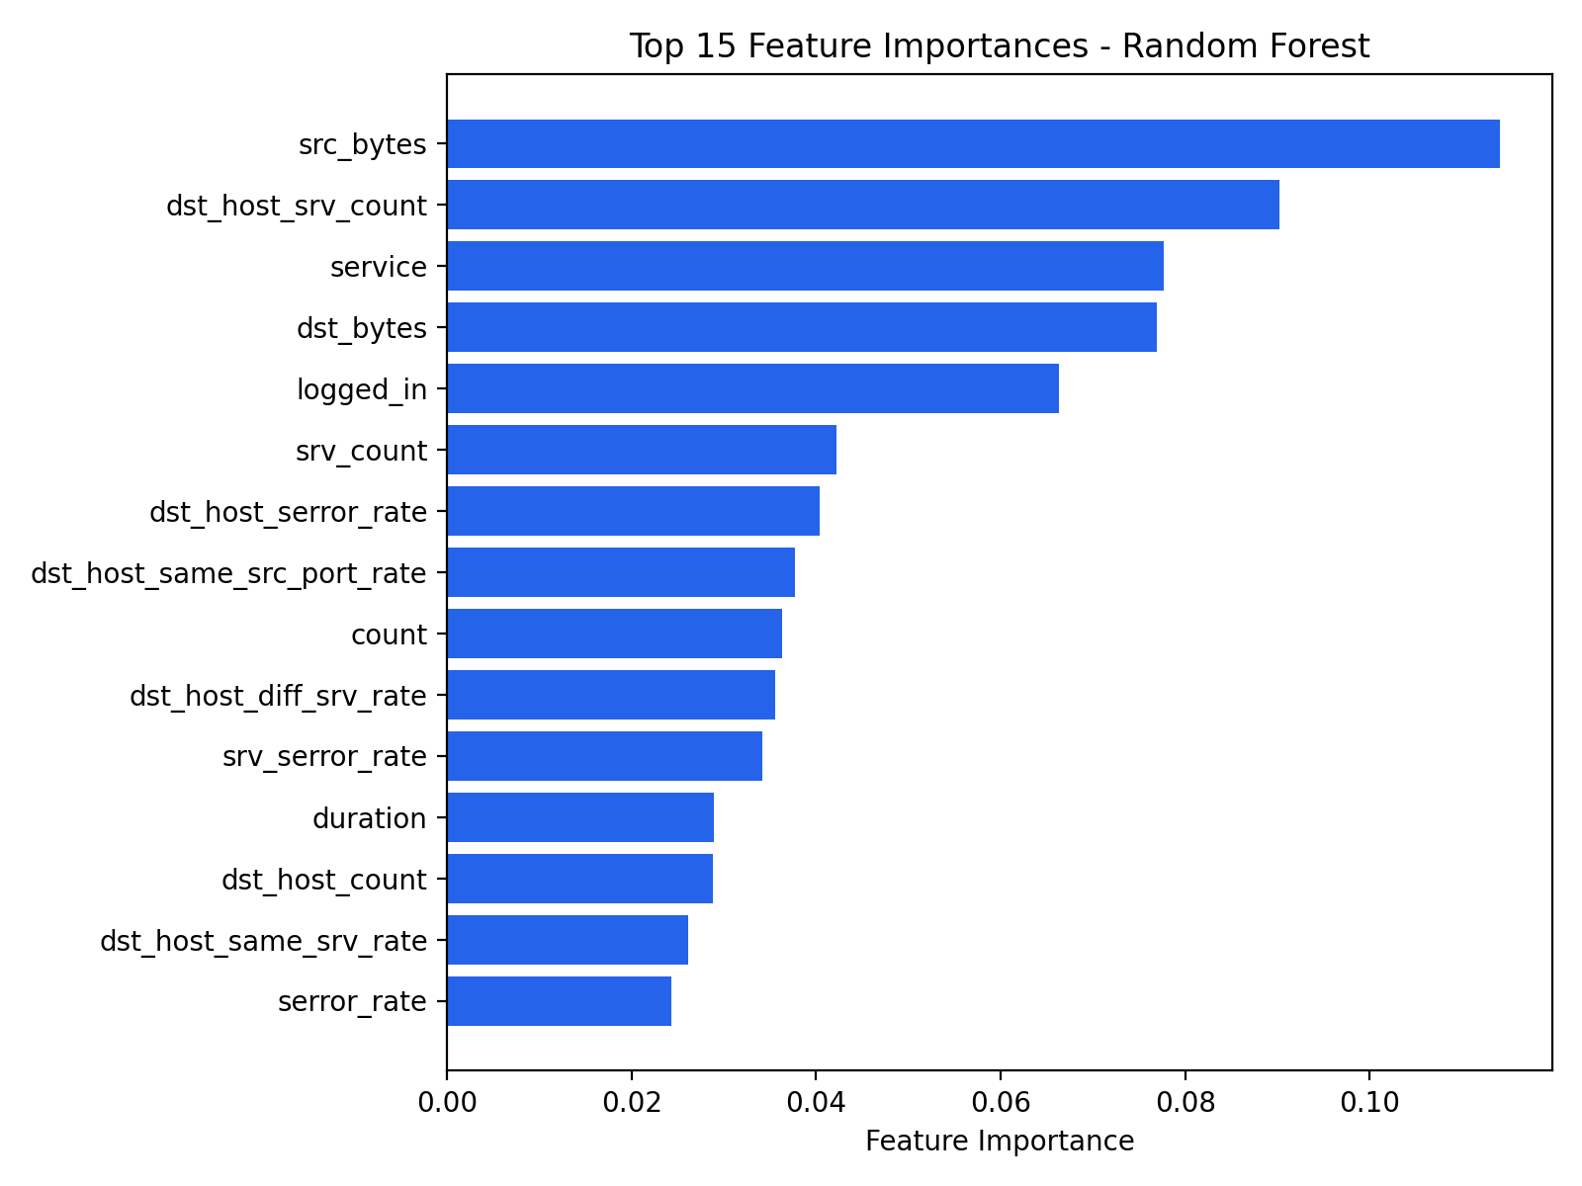
Figure 4. Top 15 feature importances from the Random Forest multiclass model.
Table 4. Top 10 Ranked Features by Gini Importance
Rank | Feature | Importance Score
1 | src_bytes (source-to-destination byte count) | 0.114
2 | dst_host_srv_count | 0.090
3 | service (network service on destination) | 0.078
4 | dst_bytes (destination-to-source byte count) | 0.077
5 | logged_in (successful login flag) | 0.066
6 | srv_count | 0.042
7 | dst_host_serror_rate | 0.040
8 | dst_host_same_src_port_rate | 0.038
9 | count | 0.036
10 | dst_host_diff_srv_rate | 0.036

5.5 Comparison with Related Work
The results obtained here are broadly consistent with the literature reviewed in Section 2. The customized ANN reported by AlQahtani et al. [3] (97.5% accuracy) outperforms the classical models evaluated in this study; however, that figure was obtained under an evaluation protocol not fully specified for comparability with the standard KDDTest+ split used here, and deep architectures generally require substantially more training data and compute for enterprise-scale deployment. Consistent with the KNIME-based comparative study [9], this work confirms that classifier performance is highly sensitive to the presence of unseen attack subtypes in the test set, and that ensemble tree-based methods (Random Forest, Gradient Boosting) provide a favorable balance of accuracy, robustness, and training efficiency relative to both simpler linear models and more computationally expensive kernel and neural methods.

6. Enterprise Deployment Considerations and Limitations

6.1 Deployment Considerations
Translating benchmark performance into a production enterprise NIDS requires attention to several practical factors beyond offline accuracy:
- Real-time inference: Tree-based ensembles (Random Forest, Gradient Boosting, Decision Tree) offer prediction latencies orders of magnitude lower than SVM and KNN in this study, making them better suited to line-rate or near-line-rate inference at enterprise scale.
- False-positive management: High attack-class precision (91-97% across models) is essential to avoid overwhelming SOC analysts; threshold tuning and staged alerting (e.g., low-confidence alerts routed to automated enrichment before analyst escalation) can further reduce alert fatigue.
- Class imbalance and rare attacks: The poor R2L/U2R performance observed here indicates that supervised models trained on historical data alone are insufficient for detecting rare or novel attack types; complementing supervised classifiers with unsupervised anomaly detection or signature-based rules for known R2L/U2R patterns is recommended.
- Concept drift: Enterprise traffic patterns evolve as applications, users, and infrastructure change. The continuous retraining feedback loop shown in Figure 1, incorporating analyst-validated labels, is necessary to prevent model staleness.
- Integration with existing security stack: Alerts should be formatted for ingestion into existing SIEM platforms and correlated with other telemetry (endpoint detection, authentication logs) rather than operating as an isolated point solution.

6.2 Limitations
This study has several limitations that should be considered when interpreting the results. First, NSL-KDD, while a well-established benchmark, was derived from network captures that do not reflect contemporary enterprise traffic (e.g., modern cloud, encrypted TLS 1.3, and IoT traffic patterns); results should be validated on more recent datasets (e.g., CICIDS2017/2018, UNSW-NB15) and, ideally, on organization-specific traffic before production deployment. Second, hyperparameters were lightly tuned rather than exhaustively optimized for each algorithm, so the relative rankings reported here represent a fair baseline rather than the maximum achievable performance of any given model. Third, the severe class imbalance for R2L and U2R attacks limits the reliability of conclusions about rare-attack detection; techniques such as SMOTE-based oversampling, cost-sensitive learning, or one-class anomaly detection were not evaluated here but represent promising extensions. Finally, this study evaluates offline, batch classification; real-time streaming performance, adversarial robustness, and behavior under concept drift were not empirically tested.

7. Conclusion and Future Work
This paper presented a comparative evaluation of eight machine learning algorithms for AI-based network intrusion detection on the NSL-KDD benchmark, alongside a modular reference architecture for enterprise deployment. Gradient Boosting and Random Forest emerged as the strongest overall performers, offering the best balance of accuracy, AUC, and computational efficiency, while all evaluated models struggled with rare R2L and U2R attack categories due to class imbalance and the presence of unseen attack subtypes in the test partition. Feature importance analysis indicated that a small set of traffic-volume, service, and host-based statistical features drives most of the discriminative power, suggesting that lightweight, lower-overhead detection pipelines are feasible for enterprise-scale deployment.
Future work should extend this evaluation to more contemporary, enterprise-representative datasets such as CICIDS2017/2018; explore deep learning and hybrid architectures (CNN-LSTM, autoencoders, and transformer-based sequence models) for capturing temporal traffic patterns; apply class-imbalance mitigation techniques (SMOTE, cost-sensitive learning, one-class/anomaly-based detection) to improve R2L and U2R detection; and evaluate adversarial robustness and real-time streaming performance under production network loads. Integrating explainable AI (XAI) techniques would further help SOC analysts trust and act on model predictions, supporting broader operational adoption of AI-based intrusion detection in enterprise security programs.

References
[1] M. Tavallaee, E. Bagheri, W. Lu, and A. A. Ghorbani, "A detailed analysis of the KDD CUP 99 data set," in Proc. 2nd IEEE Symp. Computational Intelligence for Security and Defense Applications (CISDA), Ottawa, ON, Canada, 2009, pp. 1-6.
[2] S. Solanki, C. Gupta, and K. Rai, "A survey on machine learning based intrusion detection system on NSL-KDD dataset," International Journal of Computer Applications, vol. 176, no. 30, pp. 36-39, Jun. 2020.
[3] S. A. AlQahtani, A. M. Alawwad, and A. A. Alotaibi, "Intrusion detection system with customized machine learning techniques for NSL-KDD dataset," Journal of King Saud University — Computer and Information Sciences, Elsevier.
[4] S. Hanif, T. Ilyas, and M. Zeeshan, "Intrusion detection in IoT using artificial neural networks on UNSW-15 dataset," in Proc. IEEE 16th Int. Conf. on Smart Cities: Improving Quality of Life Using ICT & IoT and AI (HONET-ICT), 2019.
[5] M. Hafeez, A. Y. Ding, and S. Tarkoma, "IoT-KEEPER: Detecting malicious IoT network activity using online traffic analysis at the edge," IEEE Transactions on Network and Service Management, vol. 17, no. 1, pp. 45-59, 2020.
[6] "Intrusion detection in NSL-KDD dataset using hybrid Self-Organizing Map model," Journal of King Saud University — Computer and Information Sciences, Elsevier, 2025.
[7] "Intrusion detection system for NSL-KDD dataset using convolutional neural networks," in Proc. 2018 2nd Int. Conf. Computer Science and Artificial Intelligence (CSAI '18), ACM, 2018, pp. 86-91.
[8] A. Warzyński and G. Kołaczek, "Intrusion detection systems vulnerability on adversarial examples," in Proc. 2018 Innovations in Intelligent Systems and Applications (INISTA), 2018.
[9] "Machine learning in network security using KNIME analytics," arXiv:2001.11489, 2020.
[10] N. Mishra, "A review of machine learning-based intrusion detection system," EAI Endorsed Transactions on Internet of Things, 2024.

