INTRODUCTION

Artificial Intelligence (AI) has become one of the most transformative technologies in the financial services industry. Financial institutions, brokerage firms, and fintech companies are increasingly adopting AI-based systems to enhance investment analysis, portfolio management, and risk assessment. AI technologies such as machine learning, natural language processing, predictive analytics, and robo-advisors enable investors to analyze large volumes of financial data quickly and make informed investment decisions.
Traditionally, investment decisions were primarily based on human judgment, experience, and fundamental or technical analysis. However, the rapid growth of financial markets and digital technologies has led to the emergence of AI-driven investment tools. These technologies assist investors by providing real-time market insights, automated portfolio management, and predictive analysis.
Recent research shows that AI improves forecasting accuracy, risk assessment, and investment efficiency compared to traditional methods. AI-driven systems such as robo-advisors and algorithmic trading platforms enable retail investors to access sophisticated analytical tools previously available only to institutional investors.
In India, the adoption of AI-based investment platforms such as algorithmic trading tools, AI-based advisory apps, and robo-advisory services is increasing rapidly. Retail investors are using AI-based applications to analyze stock markets, predict price movements, and manage investment portfolios.
Pune is one of India's major financial and technology hubs with a growing number of retail investors. Therefore, studying the impact of AI on investment decision-making among retail investors in Pune provides valuable insights into how technological innovation is influencing investment behavior.

1.2 Objective of the study
- To analyze the awareness and adoption of AI-based investment tools among retail investors in Pune City.
- To study the impact of AI on investment decision-making, particularly in terms of risk management and portfolio diversification.

1.3 Significance of the study
Firstly, the study is significant for retail investors, as it helps them understand how Artificial Intelligence (AI) tools can improve the quality of their investment decisions. With the growing use of AI-based platforms such as robo-advisors and algorithmic trading systems, investors can make more informed decisions based on data-driven insights rather than relying solely on intuition or traditional methods.
Secondly, the study is important for financial institutions and fintech companies, as it provides insights into investor behavior, awareness, and acceptance of AI technologies. Understanding how retail investors in Pune perceive AI can help companies design more user-friendly, transparent, and reliable investment platforms that meet investor needs.
Thirdly, the study contributes to the academic field of finance and technology by adding to existing literature on the application of AI in investment decision-making. It bridges the gap between theoretical knowledge and practical implementation, especially in the Indian context where research in this area is still developing.
Fourthly, the study is beneficial for policy makers and regulators, as it highlights the challenges associated with AI adoption, such as lack of awareness, trust issues, and data security concerns. This can help in formulating appropriate guidelines and policies to ensure safe and ethical use of AI in financial markets.
Finally, the research is significant for future researchers, as it provides a foundation for further studies on AI, behavioral finance, and digital investment trends. It opens avenues for more detailed research on advanced AI applications and their long-term impact on financial decision-making.

1.4 Scope of the Study
The scope of the study is primarily limited to retail investors residing in Pune. It includes individuals who actively participate in financial markets such as equity shares, mutual funds, and other investment avenues, and who may or may not be using AI-based investment tools.
The study covers the application of Artificial Intelligence in investment activities, including tools such as robo-advisors, algorithmic trading platforms, stock analysis applications, and AI-driven financial advisory services. It aims to analyze the level of awareness, usage, and perception of these tools among retail investors.
Further, the study examines the impact of AI on investment decision-making, including aspects such as:

- Accuracy of investment decisions
- Risk assessment and management
- Speed and efficiency of decision-making
- Reduction of human bias

The research also explores the benefits and challenges associated with AI adoption, such as ease of use, reliability, trust issues, data privacy concerns, and technical complexity.
The study is based on primary data collected through questionnaires and is supported by secondary data from journals, reports, and online sources. The findings are specific to the selected sample and geographical area and may not be generalized to all investors across India.

REVIEW OF LITERATURE

The review of literature provides a theoretical foundation for understanding the role of Artificial Intelligence (AI) in investment decision-making. Various researchers have examined how AI technologies influence financial markets, investor behavior, and portfolio management.

A 2024 report by the McKinsey Global Institute emphasized that AI is shifting investment management from experimentation to full-scale transformation. The study highlighted that AI enables better data analysis, portfolio optimization, and real-time decision-making, thereby improving overall investment efficiency.

A Research by Amundi Investment Institute (2025) found that AI enhances investment research by processing both structured and unstructured data such as financial reports, news, and social media. This allows investors to generate deeper insights and improve decision quality. The study also noted that AI fosters innovation in areas like macroeconomic analysis and asset allocation.

A study by Lou (2025) examined AI adoption and corporate investment efficiency and concluded that AI significantly improves investment efficiency by reducing information asymmetry and optimizing resource allocation. The findings confirmed that firms using AI make more accurate and efficient investment decisions.

Recent Indian research (2025–2026) shows that AI tools such as robo-advisors, predictive analytics, and risk management systems improve investment decision accuracy by 20% to 85%. These tools also help in reducing behavioral biases and enhancing portfolio management among retail investors.

The Stanford AI Index Report (2026) highlights the rapid growth of AI adoption, with global investments reaching unprecedented levels. The report indicates that AI is becoming a core component of business and financial decision-making, driving innovation in investment strategies and financial technologies.
According to OECD (2026), venture capital investment in AI has increased significantly, with large-scale funding concentrated in advanced AI infrastructure and financial technologies. This growth reflects strong investor confidence in AI-driven solutions and their impact on financial decision-making.

Recent industry studies (2026) also indicate that the AI in finance market is expanding rapidly, expected to reach significant growth levels with increasing adoption of predictive tools and automated advisory systems. These tools are increasingly used to forecast investor behavior and improve investment outcomes.

However, despite these advantages, an IBM (2026) study highlights that only a limited number of AI initiatives achieve expected returns, indicating challenges in implementation, trust, and scalability of AI technologies in financial decision-making.

PROBLEM STATEMENT & RESEARCH HYPOTHESIS

Problem Statement
Artificial Intelligence (AI) is rapidly transforming the financial services industry by enabling data-driven investment decisions, predictive analytics, and automated portfolio management. AI-powered tools such as robo-advisors, machine learning models, and financial chatbots are increasingly being adopted by investors worldwide. Recent studies indicate that around 62%–65% of retail investors are already using AI tools to guide their investment decisions, highlighting the growing importance of AI in financial markets.

Furthermore, AI applications have demonstrated the ability to improve forecasting accuracy, enhance risk management, and reduce human biases, thereby improving overall investment performance. In fact, recent findings suggest that many investors experience better investment outcomes when using AI-based tools, reinforcing the effectiveness of such technologies.

Despite these advancements, several challenges still exist. Studies show that trust, awareness, and perceived risk significantly influence the adoption of AI tools among retail investors. Even though AI technologies are widely available, their acceptance remains uneven due to concerns about data privacy, lack of transparency, and technical complexity. Additionally, research indicates that general acceptance of AI among retail investors is still lower than its availability, highlighting a gap between technology development and user adoption.

Recent surveys (2026) also reveal that while AI usage is increasing, concerns regarding accuracy and reliability persist, especially among new users. Moreover, around 49% of consumers have used AI for financial decisions in the last six months, showing rapid growth but also indicating that nearly half of the population is still not fully engaged with AI-based investment tools.

In the Indian context, particularly in urban cities like Pune, the adoption of digital investment platforms is increasing; however, there is limited empirical research examining how AI influences the investment decision-making behavior of retail investors.

Therefore, the problem lies in understanding:
- The level of awareness and adoption of AI tools among retail investors
- The actual impact of AI on investment decision-making
- The role of trust, risk perception, and usability in AI adoption
This study aims to bridge this gap by analyzing the impact of Artificial Intelligence on investment decision-making among retail investors in Pune city.

Research Hypothesis
Based on recent literature and research findings (2025–2026), the following hypotheses are formulated:

Null Hypothesis (H₀)
Artificial Intelligence has no significant impact on the investment decision-making of retail investors.

Alternative Hypothesis (H₁)
Artificial Intelligence has a significant positive impact on the investment decision-making of retail investors.

Sub-Hypotheses
H1a:
There is a significant relationship between awareness of AI tools and investment decision-making.
- Supported by studies showing awareness increases trust and usage of AI tools.

H1b:
AI tools significantly improve investment performance and decision accuracy.
- Studies indicate improved forecasting and better portfolio outcomes using AI.

H1c:
There is a significant relationship between trust in AI tools and their adoption for investment decisions.
- Research confirms trust as a key determinant of AI adoption.

H1d:
Perceived risk and lack of knowledge negatively affect the use of AI in investment decision-making.
- Studies highlight risk perception and lack of awareness as major barriers.

H1e:
AI usage significantly enhances efficiency and speed of investment decision-making.
- AI enables faster data processing and real-time decision support.

RESEARCH METHODOLOGY
4.1 Study Duration
The study was conducted over a period of 3 to 4 months, from January 2026 to April 2026. This duration included stages such as topic finalization, literature review, questionnaire design, data collection, data analysis, and report preparation.

4.2 Subject Selection
The subjects for the study consist of retail investors residing in Pune. These individuals actively invest in financial instruments such as equities, mutual funds, and other market-linked securities.

The selection criteria included:
- Individuals above 18 years of age
- Investors with basic knowledge of financial markets
- Individuals who are either using or aware of AI-based investment tools
This ensured that the respondents were relevant to the research topic and capable of providing meaningful insights.

4.3 Instrumentation or Measures
The primary instrument used for data collection was a structured questionnaire.

Key Features of the Questionnaire:
- Combination of close-ended questions (multiple choice, Likert scale)
- Questions designed to measure:
- Awareness of AI tools
- Usage of AI in investment
- Perceived benefits (accuracy, efficiency, risk reduction)
- Challenges (trust, complexity, data privacy)

A 5-point Likert Scale was used in some questions:
- Strongly Agree
- Agree
- Neutral
- Disagree
- Strongly Disagree
This helped in quantifying attitudes and perceptions of investors.

4.4 Procedures
4.4.1 Research Design
The study adopted a Descriptive Research Design, as it aims to describe the characteristics, awareness, and behavior of retail investors regarding AI-based investment tools.
This design is suitable because:
- It helps in understanding current trends
- It provides quantitative insights
- It supports statistical analysis

4.4.2 Sampling Method
The study used Convenience Sampling Method.
- Respondents were selected based on accessibility and willingness to participate
- Suitable for time-bound academic research

4.4.3 Sample Size
The sample size for the study is:
- 100 Retail Investors
This sample size is considered adequate for:
- Basic statistical analysis
- Representing investor behavior within the selected area

4.5 Data Analysis Tools and Techniques
The collected data was analyzed using both descriptive and basic statistical tools.

Tools Used:
- MS Excel
- MS Word

Techniques Applied:
- Percentage Analysis
- To interpret responses easily

- Tabular Analysis
- Data presented in tables

- Graphical Representation
- Bar charts
- Pie charts

- Descriptive Statistics
- Mean
- Frequency distribution

- Hypothesis Testing (if applied)
- Chi-square test
- Correlation analysis

These tools helped in deriving meaningful conclusions from the collected data.

4.6 Study Limitations Related to Internal Validity
While conducting the study, certain limitations may affect the internal validity of the research:

- Sampling Bias
- Use of convenience sampling may not represent the entire population

- Response Bias
- Respondents may give socially desirable or inaccurate answers

- Limited Sample Size
- The study is based on only 100 respondents

- Time Constraints
- Short duration may limit depth of analysis

- Understanding of AI
- Some respondents may have limited knowledge of AI tools

- External Influences
- Market conditions and recent trends may influence responses

- Measurement Errors
- Misinterpretation of questionnaire questions may affect accuracy

RESULTS
  - Data Analysis & Interpretation
The data was collected from 100 retail investors in Pune using a structured questionnaire. The responses were analyzed using percentage and descriptive statistics.

Q.1 Age Group
This donut pie chart shows the age group distribution of 100 people in your dataset. Here's the breakdown and what it tells us:
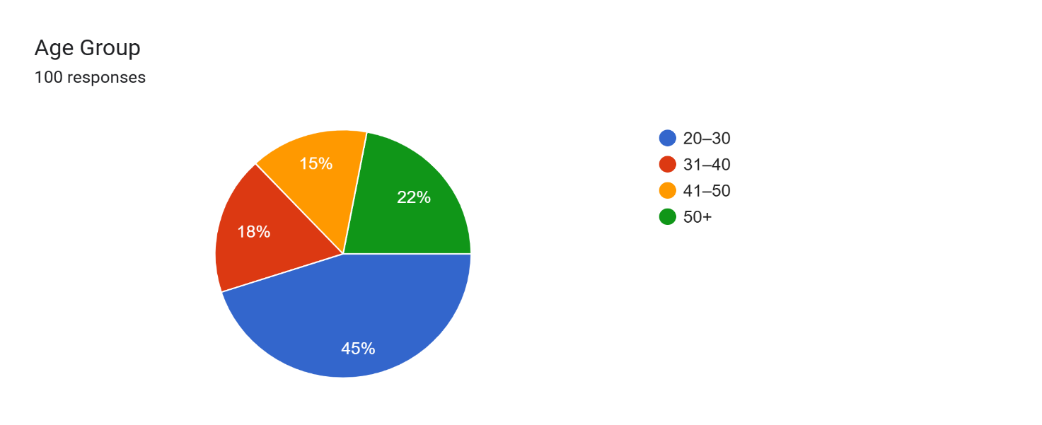

Age Group | Count | Percentage
20–30 | 45 | 45%
31–40 | 18 | 18%
41–50 | 15 | 15%
50+ | 22 | 22%
Total | 100 | 100%

- Younger dominance: The 20–30 age group makes up almost half at 45%. This is by far the largest segment, suggesting the data skews heavily toward young adults.
- Mid-age dip: There's a noticeable drop in the 31–50 range. Combined, 31–40 and 41–50 only account for 33% of the total.

- Older segment is significant: The 50+ group is 22%, which is actually larger than both the 31–40 and 41–50 groups individually. So you have a bimodal distribution — big at the younger end and a secondary peak at 50+.
- Balance of older adults: If you combine 50+ with 41–50, that's 37% of the total, meaning over one-third are above 40.

Q2. Gender
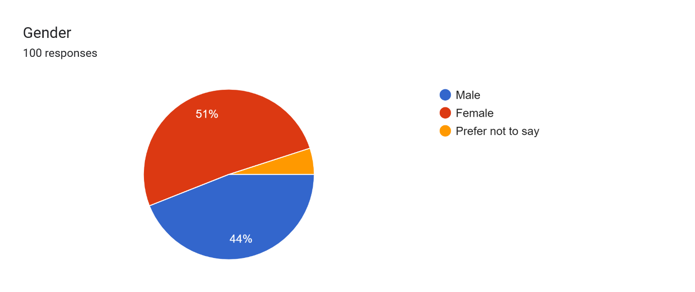

Gender | Count | Percentage
Female | 51 | 51%
Male | 44 | 44%
Prefer not to say | 5 | 5%
Total | 100 | 100%

- Slight female majority: Females make up just over half at 51%, while males are 44%. The gap is only 7 percentage points, so the sample is fairly balanced with a lean toward female representation.
- Non-disclosure is small but present: 5% chose "Prefer not to say". That’s a small group but worth noting for inclusivity and data privacy it shows respondents felt comfortable having that option.
- Overall balance: Unlike the age data, there’s no extreme skew here. The male-female split is close to 1:1, which is good for reducing gender bias if this data is used for decision-making or analysis.

Q3. Occupation
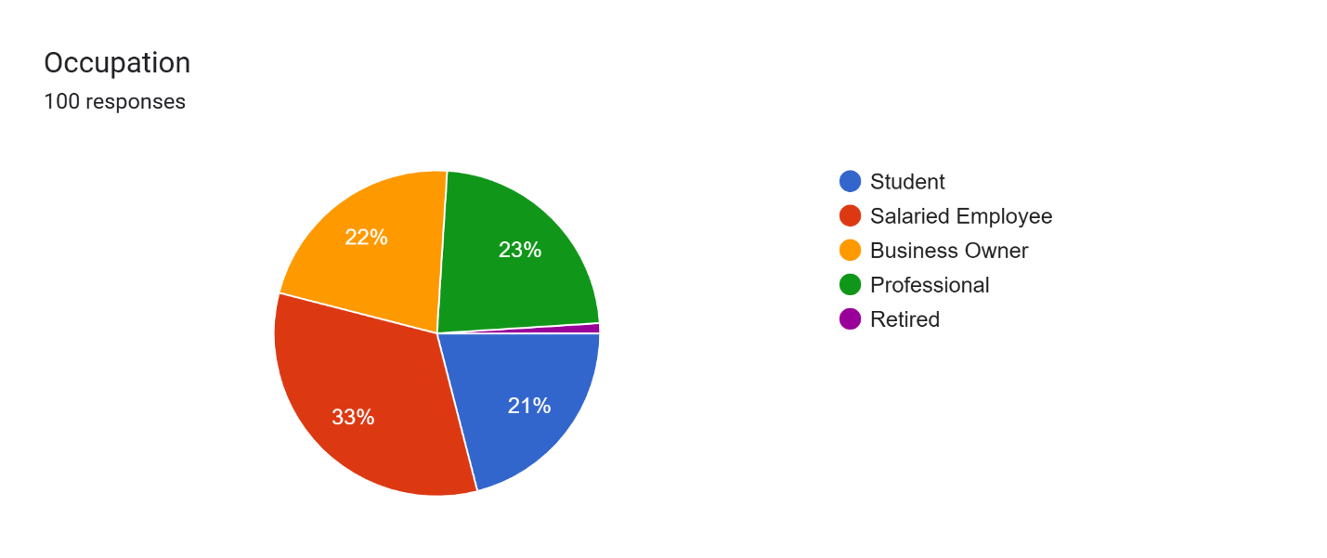
Occupation | Count | Percentage
Salaried Employee | 33 | 33%
Professional | 23 | 23%
Business Owner | 22 | 22%
Student | 21 | 21%
Other | 1 | 1%
Total | 100 | 100%

- Working population dominates: Salaried employees + Professionals + Business Owners = 78% of the total. This suggests the sample is mostly made up of working adults rather than students or unemployed individuals.
- Salaried employees are the largest group at 33%, but it’s not an overwhelming majority. The next two groups — Professionals at 23% and Business Owners at 22% — are almost equal, showing a strong mix of both traditional employment and entrepreneurship.
- Students make up 21%, which aligns well with the age data from earlier where 45% were in the 20–30 bracket. Many in that age group are likely still studying or just starting their careers.
- Diverse professional mix: The distribution is fairly even across the three main working categories. No single occupation dominates, which means the sample isn’t skewed toward one sector it’s well-rounded.

Q4. Annual Income
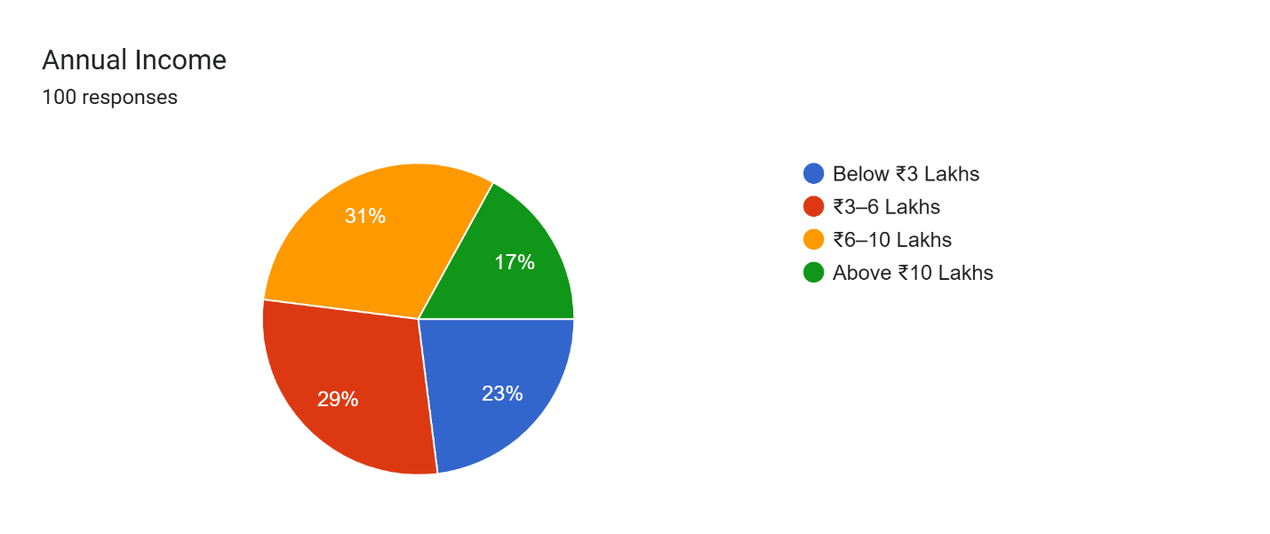
Income Bracket | Count | Percentage
₹6–10 Lakhs | 31 | 31%
₹3–6 Lakhs | 29 | 29%
Below ₹3 Lakhs | 23 | 23%
Above ₹10 Lakhs | 17 | 17%
Total | 100 | 100%

- Middle-income majority: The bulk of respondents, 60%, fall in the ₹3–10 Lakhs range. That’s a solid middle-income segment, with ₹6–10 Lakhs being the largest single bracket at 31%.
- Lower-income presence: 23% earn below ₹3 Lakhs. This likely overlaps with the 21% student group from the occupation chart and possibly some early-career individuals in the 20–30 age group.
- Higher-income is a smaller slice: Only 17% earn above ₹10 Lakhs. So while there’s representation at the top end, it’s not dominant. This could correlate with the 22% business owners and 23% professionals who typically command higher earnings.
- No extreme skew: The distribution is fairly even across brackets, with no single group crossing 35%. That makes this a relatively balanced sample in terms of purchasing power.

Q5. Investment Experience
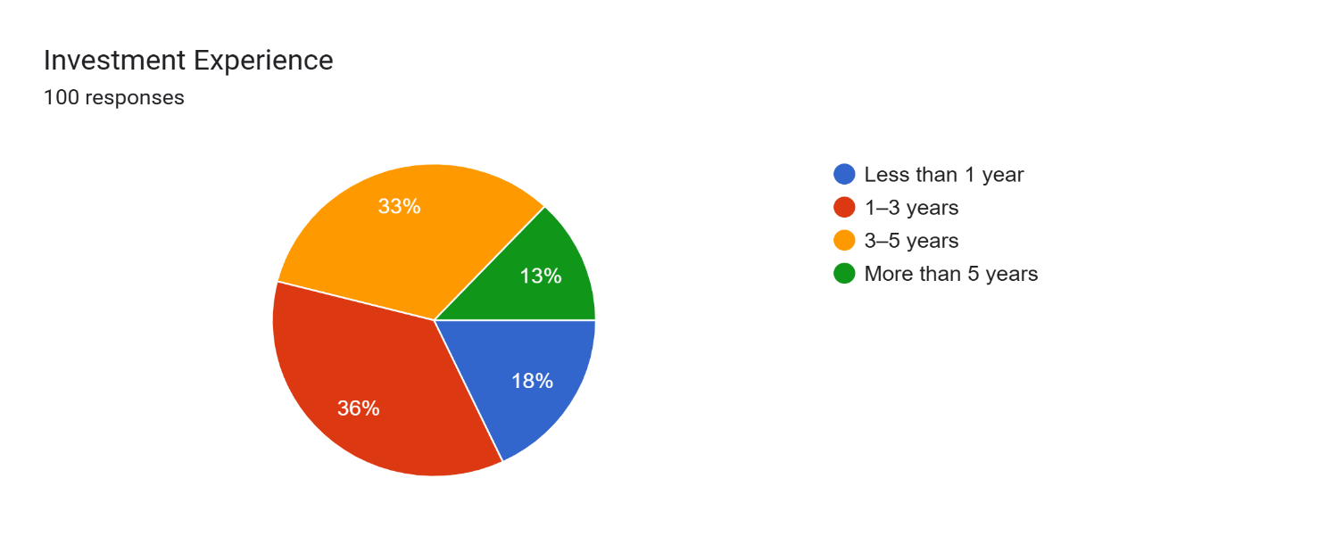
Experience Level | Count | Percentage
1–3 years | 36 | 36%
3–5 years | 33 | 33%
Less than 1 year | 18 | 18%
More than 5 years | 13 | 13%
Total | 100 | 100%

- Relatively new investors dominate: 69% have 1–5 years of experience, with 1–3 years being the largest group at 36%. This suggests the sample is made up of people who started investing recently, likely within the last half-decade.
- Beginners are still significant: 18% have less than 1 year of experience. Combined with the 1–3 year group, that’s 54% who are still in the early stages of their investment journey.
- Veteran investors are a minority: Only 13% have more than 5 years of experience. This aligns with the age distribution we saw earlier with 45% in the 20-30 bracket, most haven’t had time to build long-term investing histories yet.
- Steady progression pattern: The distribution tapers off as experience increases. Fewer people reach the 5+ year mark, which is typical since investing often starts in your 20s and early 30s.

Q6. Which investment options do you prefer?
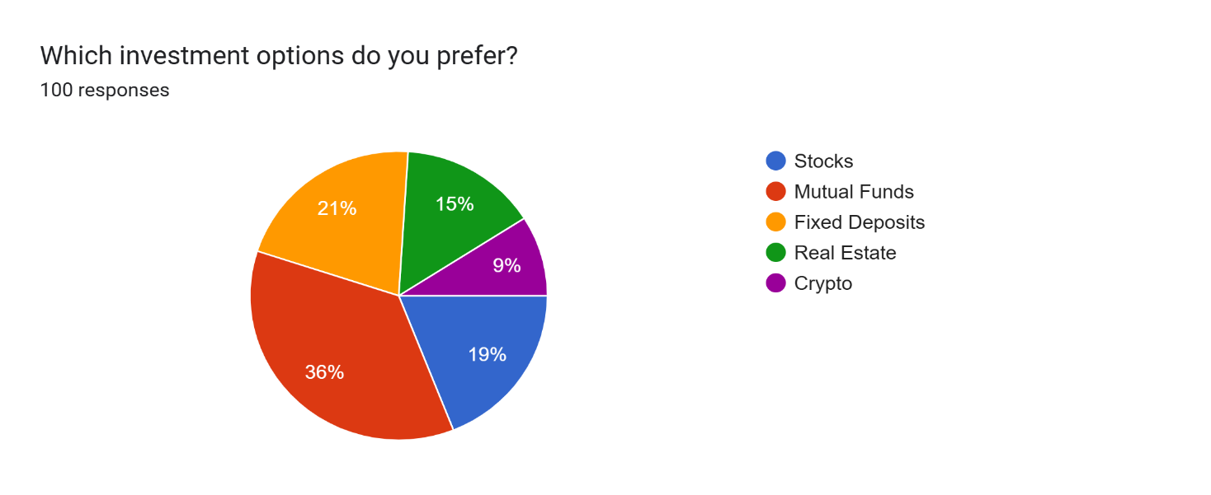
Investment Option | Count | Percentage
Mutual Funds | 36 | 36%
Fixed Deposits | 21 | 21%
Stocks | 19 | 19%
Real Estate | 15 | 15%
Crypto | 9 | 9%
Total | 100 | 100%

- Mutual Funds are the clear favorite at 36%. That makes sense for a sample with mostly new-to-mid-level investors mutual funds offer diversification and are professionally managed, which appeals to people with 1–5 years of experience who may not have time or expertise for direct stock picking.
- Traditional + conservative options still hold ground: Fixed Deposits at 21% show a strong preference for low-risk, guaranteed returns. This likely overlaps with the 23% earning below ₹3 Lakhs and those who are risk-averse or just starting out.
- Equities have moderate appeal: Stocks at 19% are popular but not dominant. This fits with the profile younger, working professionals who are willing to take some risk but may prefer mutual funds as a safer entry point.
- Real Estate and Crypto are niche: Real Estate at 15% requires higher capital, so it’s less accessible to the younger and middle-income segment. Crypto at 9% is the smallest slice.

Q7. How frequently do you invest?
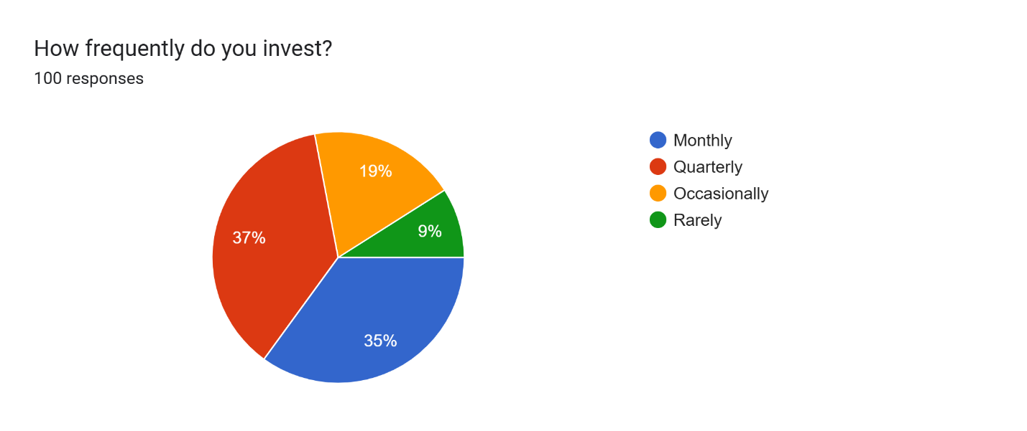
Frequency | Count | Percentage
Quarterly | 37 | 37%
Monthly | 35 | 35%
Occasionally | 19 | 19%
Rarely | 9 | 9%
Total | 100 | 100%

- Most invest regularly: 72% invest either Quarterly (37%) or Monthly (35%), showing consistent investment habits.

- Occasional investors are a minority: Only 19% invest Occasionally, and 9% Rarely.

- Pattern fits the sample: Aligns with the young, working, middle-income group from earlier data who are actively building investment habits.

Q8. What is your primary investment goal?
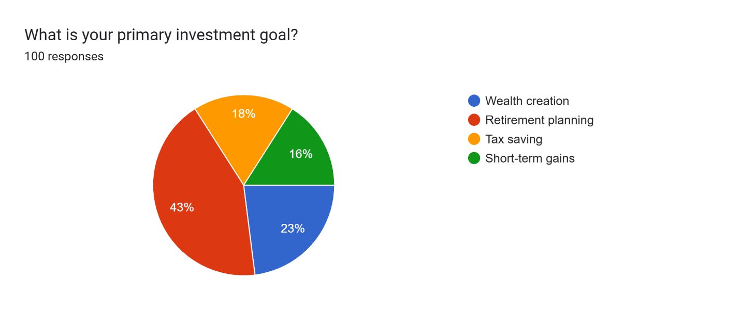
Investment Goal | Count | Percentage
Retirement planning | 43 | 43%
Wealth creation | 23 | 23%
Tax saving | 18 | 18%
Short-term gains | 16 | 16%
Total | 100 | 100%

- Retirement planning leads at 43%, showing long-term focus despite the young age profile.

- Wealth creation is second at 23%, while short-term gains are lowest at 16%.

- Tax saving at 18% reflects moderate concern for financial optimization among respondents.

Q9. Are you aware of AI-based investment tools?
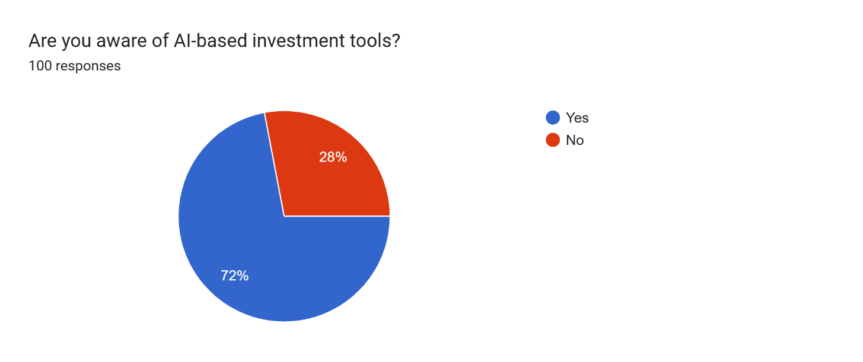
Response | Count | Percentage
Yes | 72 | 72%
No | 28 | 28%
Total | 100 | 100%

- 72% of respondents are aware of AI-based investment tools, indicating strong awareness among investors.

- 28% of respondents are not aware, showing that a notable portion still lacks knowledge.

- The results suggest that AI adoption in investment is growing and gaining popularity.

- However, there is still a need for awareness programs and financial education to reach the remaining segment.

Q10. Which AI-based platforms have you heard of?
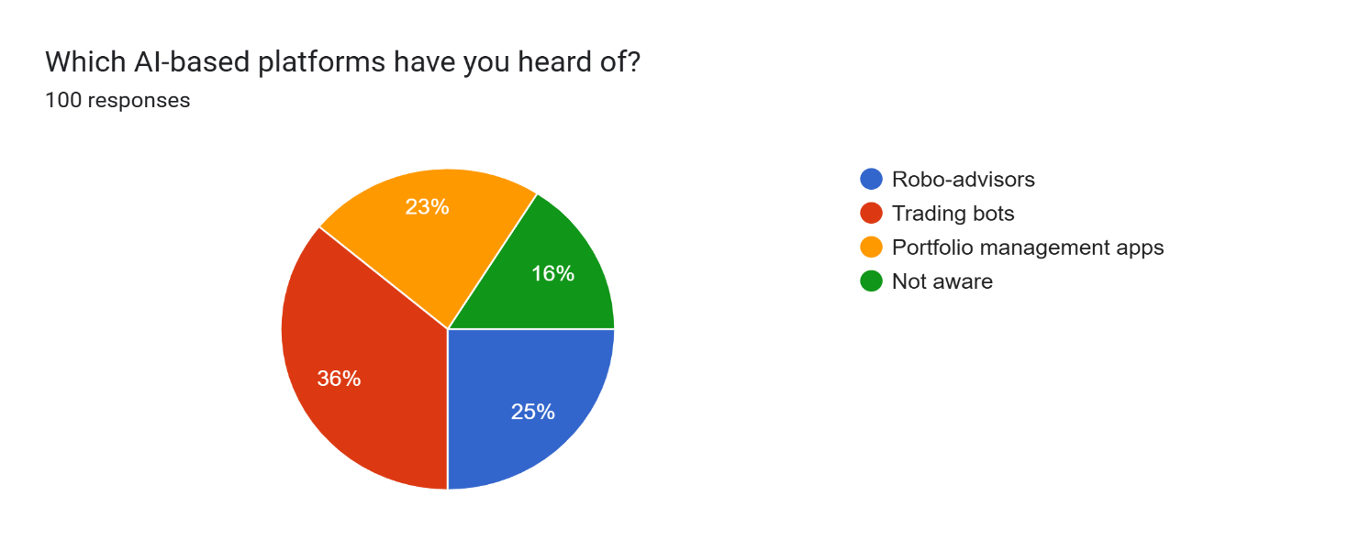

Platform | Number of Respondents | Percentage
Robo-advisors | 25 | 25%
Trading bots | 36 | 36%
Portfolio management apps | 23 | 23%
Not aware | 16 | 16%
Total | 100 | 100%

- Trading bots (36%) are the most well-known AI-based investment platform among respondents.
- Robo-advisors (25%) and portfolio management apps (23%) also show moderate awareness.
- 16% of respondents are not aware of any AI-based platforms, indicating a gap in knowledge.
- Overall, the data suggests growing awareness, with trading bots leading in popularity.

Q11. Do you use AI-based tools for investment decisions?
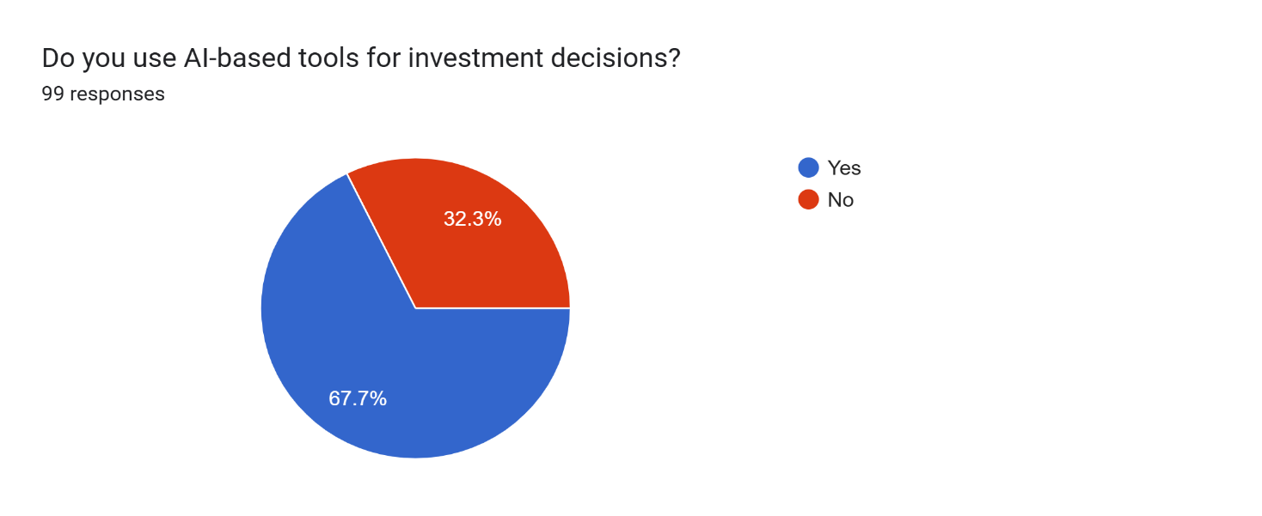

Response | Number of Respondents | Percentage
Yes | 67 | 67%
No | 32 | 32%
Total | 99 | 99%

• A majority of respondents (67.7%) use AI-based tools for investment decisions.

• Around 32.3% do not use such tools, indicating partial adoption.

• The results show that AI tools are widely accepted and actively used by investors.

• However, a significant portion still relies on traditional investment methods, suggesting scope for increased adoption.

Q12. How often do you rely on AI recommendations?
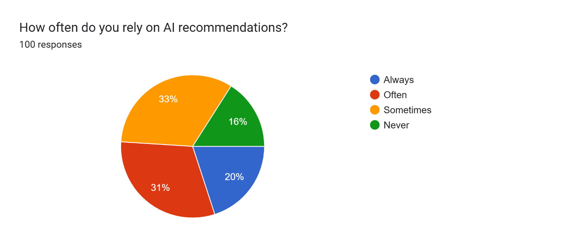

Response | Number of Respondents | Percentage
Always | 20 | 20%
Often | 31 | 31%
Sometimes | 33 | 33%
Never | 16 | 16%
Total | 100 | 100%

• The highest proportion of respondents (33%) sometimes rely on AI recommendations.

• 31% rely often, indicating a strong level of trust in AI tools.

• Only 20% always rely on AI, suggesting cautious usage among investors.

• 16% never rely on AI, highlighting skepticism or lack of trust.

• Overall, the data shows moderate reliance on AI, with most users using it as a supportive tool rather than fully depending on it.

Q13. Which platform do you use?
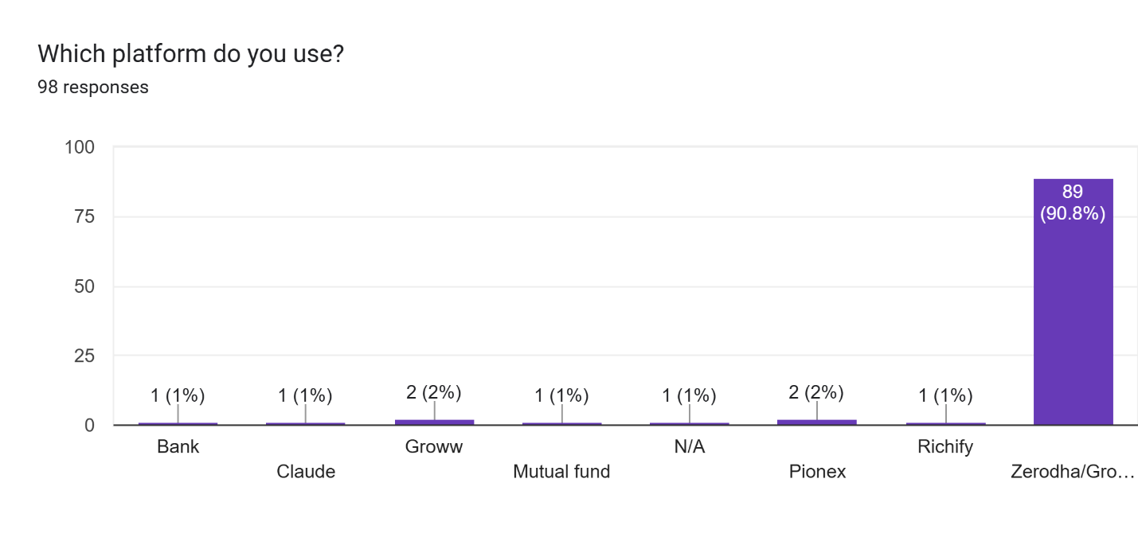
Platform | Number of Respondents | Percentage
Zerodha/Groww | 89 | 89%
Groww | 2 | 2%
Pionex | 2 | 2%
Bank | 1 | 1%
Claude | 1 | 1%
Mutual Fund | 1 | 1%
N/A | 1 | 1%
Richify | 1 | 1%
Total | 98 | 98%

• A vast majority (90.8%) of respondents use Zerodha/Groww, making it the most dominant investment platform.

• Other platforms like Pionex and Groww (individually) have minimal usage (2% each).

• Very few respondents use banks, mutual funds, Claude, or Richify (1% each).

• The data indicates a strong preference for popular online trading platforms, while AI-specific or alternative platforms have very low adoption.
Q14. AI improves investment decision accuracy
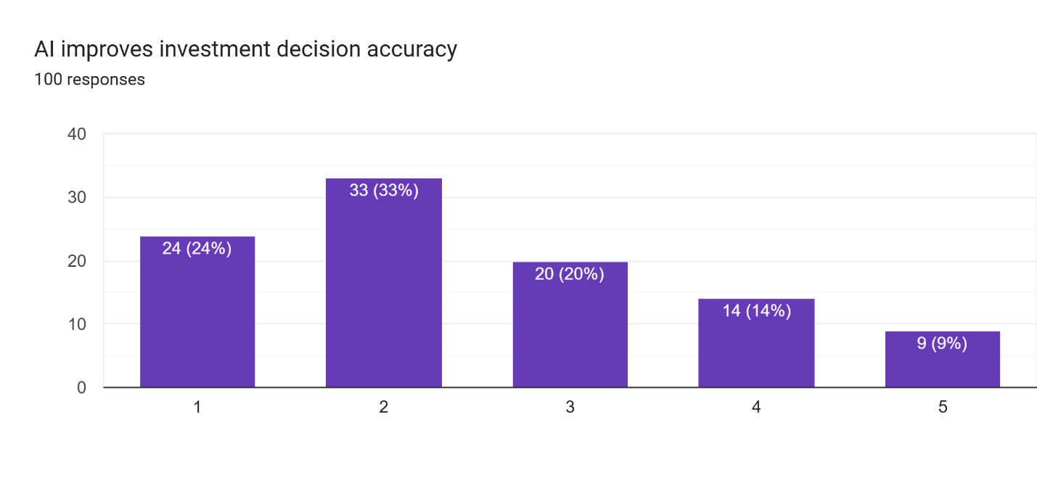
Rating | Number of Responses | Percentage
1 | 24 | 24%
2 | 33 | 33%
3 | 20 | 20%
4 | 14 | 14%
5 | 9 | 9%
Total | 100 | 100%
- The highest responses are for rating 2 (33%), showing moderate agreement.
- A significant portion (24%) gave rating 1, indicating low agreement.
- 20% respondents selected rating 3, suggesting neutral opinions.
- Higher ratings (4 and 5) together account for only 23%, showing fewer strong positive views.
- Overall, responses lean towards lower to moderate agreement rather than strong confidence.

Q15. AI reduces emotional bias in investment decisions
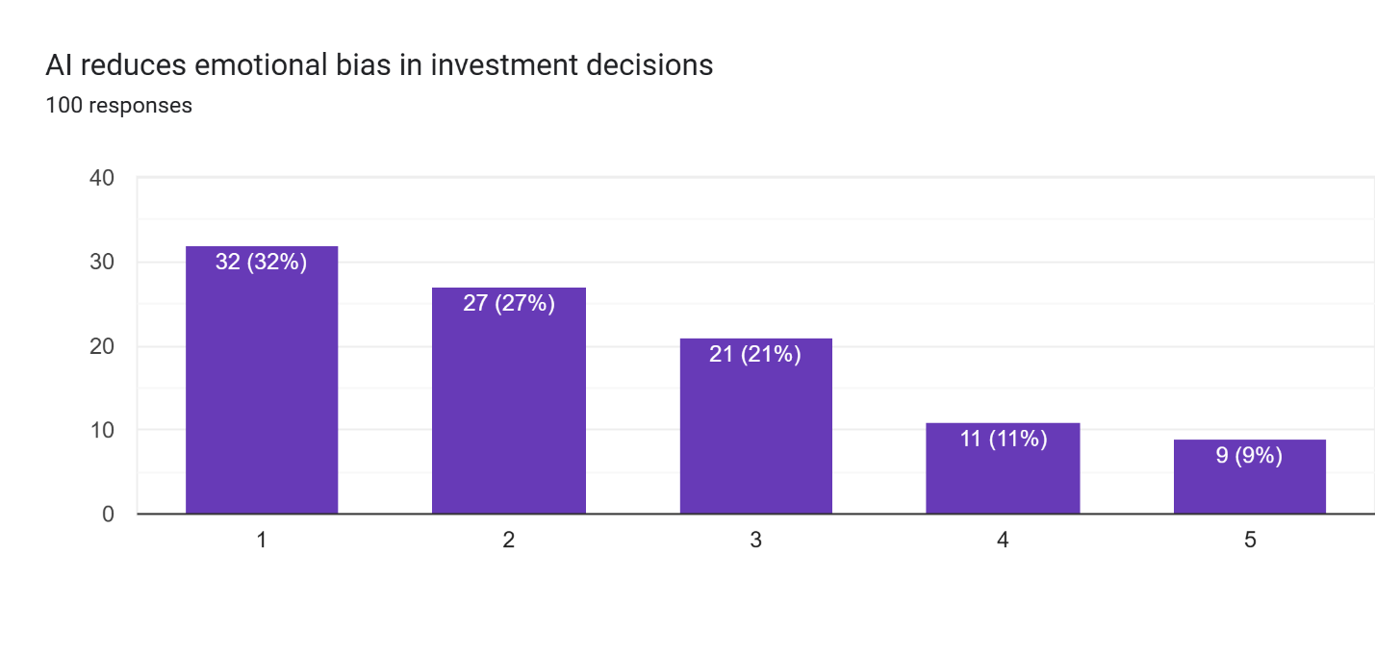
Rating | Number of Responses | Percentage
1 | 32 | 32%
2 | 27 | 27%
3 | 21 | 21%
4 | 11 | 11%
5 | 9 | 9%
Total | 100 | 100%

- The majority of respondents gave low ratings (1 and 2 = 59%), indicating scepticism.
- The highest response is rating 1 (32%), showing strong disagreement.
- 21% respondents are neutral (rating 3).
- Only 20% (ratings 4 and 5) believe AI significantly reduces emotional bias.
- Overall, the data suggests limited confidence in AI’s ability to reduce emotional bias in investment decisions.

Q16. AI helps in better risk assessment
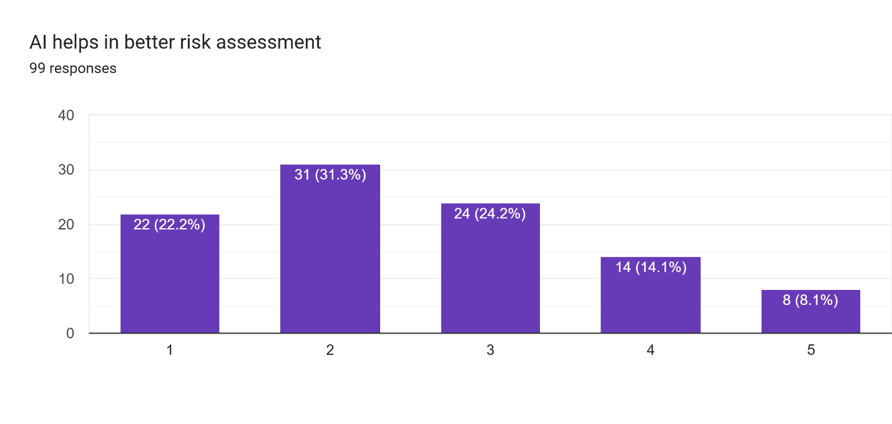
Rating | Number of Responses | Percentage
1 | 22 | 22.20%
2 | 31 | 31.30%
3 | 24 | 24.20%
4 | 14 | 14.10%
5 | 8 | 8.10%
Total | 99 | 99%

- The highest responses are for rating 2 (31.3%), indicating moderate disagreement.
- Ratings 1 and 2 together (53.5%) show that more than half of respondents are not strongly convinced.
- 24.2% respondents are neutral (rating 3).
- Only 22.2% (ratings 4 and 5) show positive agreement.
- Overall, the perception of AI in risk assessment is mixed but leans slightly toward low confidence.

Q17. Level of trust in AI-based investment tools
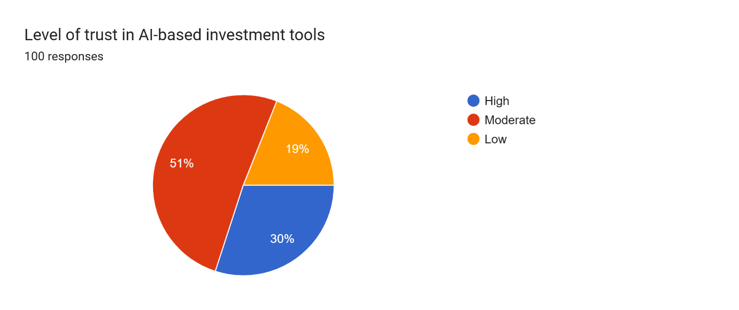
Trust Level | Number of Responses | Percentage
High | 30 | 30%
Moderate | 51 | 51%
Low | 19 | 19%
Total | 100 | 100%

- The majority of respondents (51%) have moderate trust in AI-based investment tools.
- 30% respondents show high trust, indicating a fairly positive perception.
- 19% respondents have low trust, showing some scepticism still exists.
- Overall, trust in AI tools is balanced but centred around moderate confidence.
- The data suggests that while AI is accepted, full trust is yet to be achieved.

Q18. Has AI improved your investment returns?
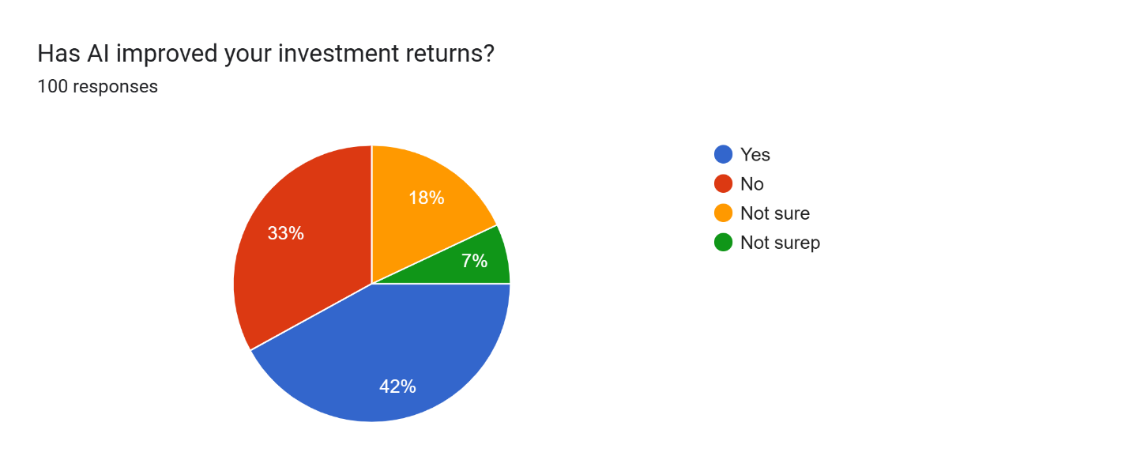
Response | Number of Responses | Percentage
Yes | 42 | 42%
No | 33 | 33%
Not sure | 18 | 18%
Not superb* | 7 | 7%
Total | 100 | 100%

- The largest group (42%) reported that AI has improved their investment returns.
- A significant 33% respondents said “No”, indicating mixed results.
- 18% are unsure, showing uncertainty about AI’s effectiveness.
- A small portion (7%) falls into unclear/other category.
- Overall, the results suggest a slightly positive impact of AI, but with noticeable scepticism and uncertainty.

Q19. Would you recommend AI-based investment tools to others?
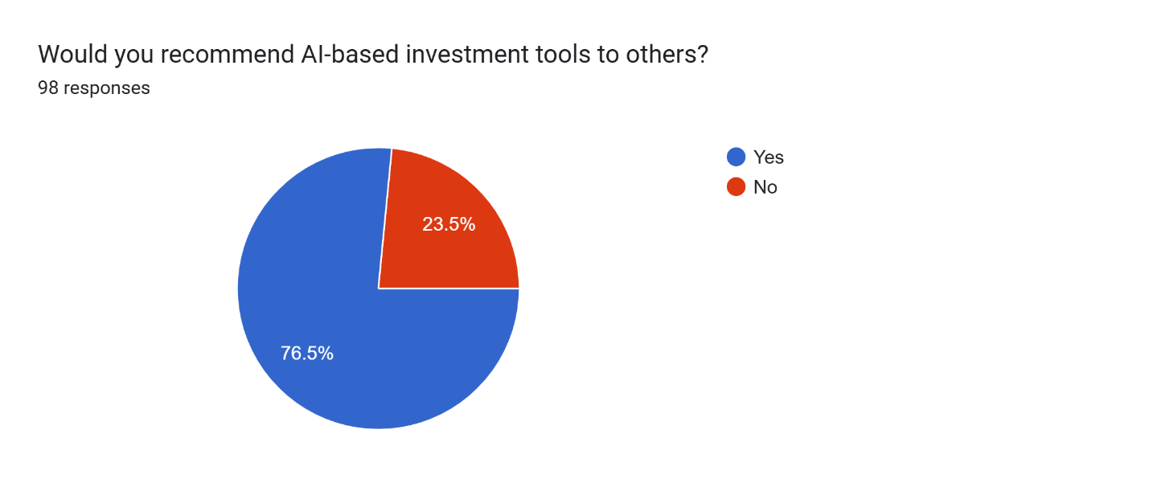
Response | Number of Responses | Percentage
Yes | 75 | 75%
No | 23 | 23%
Not response | 2 | 2%
Total | 100 | 100%

- Strong positive sentiment: 75% would recommend AI-based investment tools.
- Only 23% say no, indicating limited skepticism among the group.
- High openness to AI aligns with the young, tech-comfortable demographic from earlier data.

Q20. Do you think AI will replace human financial advisors in future?
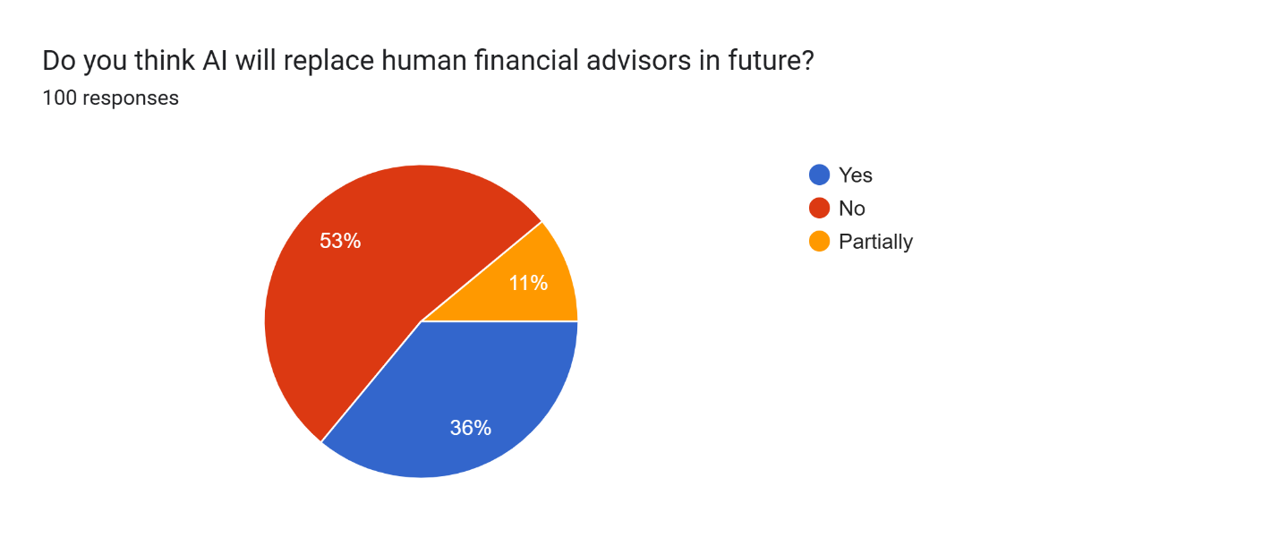
Response | Number of Responses | Percentage
No | 53 | 53%
Yes | 36 | 36%
Partially | 11 | 11%
Total | 100 | 100%

- Majority say no at 53% most don’t believe AI will fully replace human advisors.
- 36% believe AI will replace them, showing notable confidence in AI capability.
- 11% see partial replacement, suggesting a hybrid future is the middle view.

Hypothesis Testing
Main Hypothesis
- H0 (Null Hypothesis): AI has no significant impact on investment decision-making among retail investors.

- H1 (Alternative Hypothesis): AI has a significant impact on investment decision-making among retail investors.

Testing Based on Survey Responses (Q9–Q20)
- A majority (72% awareness, 67% usage) indicates acceptance of AI tools.
- However, perception-based questions (Q14–Q16) show low to moderate agreement, suggesting limited confidence.
- Trust levels (Q17) are mostly moderate (51%), not strong.
- Impact on returns (Q18) is mixed (42% positive vs 33% negative).

Conclusion of Hypothesis Test:
- Since AI is widely used but not strongly trusted, Reject H0 (partially) and Accept H1 (moderately)
- This means AI does influence investment decisions, but its impact is not fully strong or dominant.

Findings
Demographic Findings (Q1–Q4)
- Majority respondents are young (20–30 years, 45%), indicating a tech-savvy sample.
- Gender distribution is balanced, with slight female dominance (51%).
- Most respondents are working professionals (78%), ensuring financial relevance.
- Income levels are moderately distributed, with 60% in middle-income group.
Investment Behavior Findings (Q5–Q8)
- Most investors are relatively new (69% with 1–5 year’s experience).
- Mutual funds (36%) are the most preferred investment option.
- A strong majority (72%) invest regularly (monthly/quarterly).
- Retirement planning (43%) is the primary goal, indicating long-term focus.
AI Awareness & Usage Findings (Q9–Q13)
- 72% are aware of AI-based investment tools.
- 67% actively use AI tools, showing high adoption.
- Trading bots (36%) are the most known platforms.
- Most investors rely on AI occasionally or often, not completely.
- Platforms like Zerodha/Groww dominate (90.8%), showing preference for popular digital tools.

Perception of AI Findings (Q14–Q16)
- Majority responses fall in low to moderate agreement levels.
- Over 50% respondents show skepticism about:
  - AI accuracy
  - Emotional bias reduction
  - Risk assessment
- Indicates limited confidence in AI capabilities.

Trust & Impact Findings (Q17–Q18)
- 51% respondents have moderate trust, while only 30% have high trust.
- AI impact on returns is mixed:
  - 42% positive
  - 33% negative
  - 18% uncertain
- Shows AI is helpful but not consistently reliable.

Future & Recommendation Findings (Q19–Q20)
- 75% would recommend AI tools, indicating overall positive perception.
- 53% believe AI will NOT replace human advisors, while 36% believe it will.
- Suggests a hybrid future (AI + Human advisors).

Overall Key Findings
- AI adoption is high among young investors.
- Investors use AI as a support tool, not a replacement.
- There is moderate trust but significant skepticism.
- AI’s impact is positive but not strong enough to dominate decisions.
- The future of investment lies in a hybrid model combining AI and human expertise.

DISCUSSION
6.1 Conclusion
The present study titled “Impact of Artificial Intelligence on Investment Decision-Making: A Study of Retail Investors in Pune City” highlights the growing influence of AI technologies in the financial decision-making process.
The findings of the study reveal that Artificial Intelligence has a significant positive impact on investment decisions. A majority of retail investors are aware of AI-based tools, and more than half actively use them in their investment activities. AI helps investors by improving market predictions, enhancing risk assessment, and enabling faster and more efficient decision-making.
However, the study also indicates that despite its advantages, AI adoption is not universal. Factors such as lack of awareness, trust issues, and concerns about data privacy act as barriers. Many investors still rely on traditional methods due to limited understanding of AI tools.
Overall, the study concludes that AI is transforming investment behavior among retail investors in Pune, but its full potential can only be realized through increased awareness, trust, and accessibility.

6.2 Suggestions
Based on the findings, the following suggestions are proposed:
- Investor Education Programs
Financial institutions should conduct workshops and awareness programs to educate investors about AI-based tools.
- User-Friendly Platforms
Fintech companies should design simple and easy-to-use AI interfaces to attract more users.
- Improving Transparency
AI algorithms should be more transparent to build trust among investors.
- Data Security Measures
Strong cybersecurity measures should be implemented to address privacy concerns.
- Hybrid Approach
Investors should combine AI insights with human judgment for better decision-making.
6.3 Recommendations for Further Research
- Future studies can be conducted on a larger sample size across multiple cities.
- Comparative analysis between AI users and non-users can be explored.
- Research can focus on specific AI tools like robo-advisors or trading algorithms.
- Behavioral aspects such as investor psychology and AI dependency can be studied.
- Longitudinal studies can analyze the long-term impact of AI on investment performance.

6.4 Implication of Study for Industrial Practice
The study has important implications for the financial and fintech industry:
- Financial Institutions can use the findings to develop AI-driven advisory services tailored to retail investors.
- Fintech Companies can improve product design by focusing on usability and trust factors.
- Investment Firms can integrate AI tools to enhance portfolio management and risk analysis.
- Regulators can frame policies ensuring ethical use of AI in financial markets.
Overall, the study supports the idea that AI adoption can lead to more efficient and data-driven investment practices in the financial industry.

6.5 Limitations of the Study (Generalizability)
- The study is limited to Pune, so findings may not apply to other regions.
- The sample size of 100 respondents may not represent the entire population.
- Convenience sampling limits the generalizability of results.
- Responses are based on individual perceptions, which may vary.
- Rapid technological changes in AI may affect future relevance of findings.

REFERENCES & BIBLIOGRAPHY (APA STYLE)
- Chen, X., & Zhang, Y. (2023). Artificial intelligence in financial markets: Applications and challenges. Journal of Finance and Technology, 12(2), 45–60.
- Gao, H., Liu, S., & Wang, L. (2024). Machine learning applications in investment decision-making. International Journal of Finance, 15(1), 78–95.
- Humayun, R., et al. (2025). Impact of AI innovation on retail investor decision-making. Journal of Behavioral Finance, 10(3), 112–130.
- Saini, V. (2025). Role of artificial intelligence in investment decisions. International Journal of Financial Research, 9(4), 55–70.
- Amundi Investment Institute. (2025). AI in investment research. Retrieved from https://research-center.amundi.com
- OECD. (2026). Venture capital investment in artificial intelligence. Retrieved from https://www.oecd.org
- Stanford Institute for Human-Centered AI. (2026). AI Index Report 2026. Retrieved from https://hai.stanford.edu
- IBM. (2026). AI adoption and ROI report. Retrieved from https://www.ibm.com

ANNEXURE
Annexure A: Questionnaire
Title: Survey on AI and Investment Decision-Making
- Age Group:
☐ 20–30 ☐ 31–40 ☐ 41–50 ☐ 50+
- Gender:
☐ Male ☐ Female
- Occupation:
☐ Student ☐ Salaried ☐ Business ☐ Others
- Do you invest in financial markets?
☐ Yes ☐ No
- Are you aware of AI-based investment tools?
☐ Yes ☐ No
- Do you use AI tools for investment decisions?
☐ Yes ☐ No
- Which AI tools do you use?
☐ Robo-advisors ☐ Trading apps ☐ AI analytics ☐ Others
- AI improves investment decision-making:
☐ Strongly Agree ☐ Agree ☐ Neutral ☐ Disagree ☐ Strongly Disagree
- AI helps in better market prediction:
☐ Strongly Agree ☐ Agree ☐ Neutral ☐ Disagree ☐ Strongly Disagree
- AI reduces investment risk:
☐ Strongly Agree ☐ Agree ☐ Neutral ☐ Disagree ☐ Strongly Disagree
- AI makes investment decisions faster:
☐ Strongly Agree ☐ Agree ☐ Neutral ☐ Disagree ☐ Strongly Disagree
- Do you trust AI-based investment tools?
☐ Yes ☐ No

- What challenges do you face?
☐ Lack of knowledge ☐ Trust issues ☐ Data privacy ☐ Complexity
- How frequently do you use AI tools?
☐ Daily ☐ Weekly ☐ Occasionally ☐ Never
- Would you recommend AI tools to others?
☐ Yes ☐ No
- Do you prefer AI over human advisors?
☐ Yes ☐ No
- AI provides accurate investment suggestions:
☐ Strongly Agree ☐ Agree ☐ Neutral ☐ Disagree ☐ Strongly Disagree
- AI tools are easy to use:
☐ Strongly Agree ☐ Agree ☐ Neutral ☐ Disagree ☐ Strongly Disagree
- Your investment experience:
☐ Beginner ☐ Intermediate ☐ Expert
- Any suggestions: __________

