Antibacterial Effects of Garlic (Allium sativum) Against Household Bacteria: A Comparative Study with Azithromycin by Akshith Duvvi

Abstract
This study investigates the antibacterial effects of garlic (Allium sativum) extract against household bacteria collected from contaminated surfaces such as toilet seats and door handles. The objective was to compare the effect of garlic extract at three concentrations (low, medium, and high) with a standard antibiotic, azithromycin. Agar plates were inoculated with bacterial samples, and sterile discs infused with either garlic extract or azithromycin were applied. Zones of inhibition were measured to assess antimicrobial activity. Results showed that garlic produced a concentration-dependent inhibitory effect, with larger inhibition zones at higher concentrations. However, azithromycin consistently demonstrated greater antibacterial activity than garlic. These findings suggest that while garlic exhibits measurable antimicrobial properties against diverse household bacteria, its effectiveness is lower than that of a broad-spectrum antibiotic. Garlic may thus hold potential as a natural supplementary antimicrobial agent, but it is not a substitute for conventional antibiotics

Introduction
Bacteria are prokaryotic unicellular organisms that are found everywhere in our environment, including on common household surfaces such as door handles, toilet seats, and countertops. While many bacteria are harmless, some can cause infections or illnesses if they come into contact with the human body. Controlling bacterial growth in households is therefore essential to maintain good health and prevent infectious diseases. Traditionally, antibiotics like azithromycin are used to combat bacterial infections effectively. However, the overuse of antibiotics has led to the rise of antibiotic-resistant bacteria, making it increasingly important to explore alternative or supplementary antimicrobial agents to tackle this problem effectively.
Garlic (Allium sativum) has been used for centuries as a natural remedy due to its reported medicinal properties, including antibacterial, antifungal, and antiviral effects. Its bioactive compounds, such as allicin, have been shown to inhibit the growth of certain infectious bacteria by disrupting cell walls and interfering with essential cellular processes. Sharifi-Rad et.al [1] suggested that garlic may be effective against a variety of bacterial strains, but its potency compared to standard antibiotics remains unclear.
This study aims to investigate the antibacterial effects of garlic extract on bacteria collected from household surfaces. Specifically, it evaluates the efficacy of garlic extract at three concentrations—low, medium, and high—and compares the results with the standard antibiotic azithromycin. By measuring zones of inhibition on agar plates, this experiment seeks to determine whether garlic can serve as a natural, supplementary antimicrobial agent in everyday environments. Understanding the antibacterial potential of garlic could provide insights into alternative methods for reducing bacterial contamination in households and promoting general health, without having the danger of giving rise to new anti-bacterial resistant bacteria strains.

Materials and Methods

Materials:
- Petri dishes containing nutrient agar
- Raw garlic paste (for preparing low, medium, and high concentrations)
- Sterile cotton swabs
- Filter paper discs
- Standard antibiotic: azithromycin
- Marker for labelling plates
- Ruler for measurement
Methods:
- Preparation of bacterial samples: Bacteria were collected from common household surfaces, including door handles and toilet seats, using sterile cotton swabs. The swabs were then used to inoculate nutrient agar plates by streaking the bacteria evenly across the surface.
- Preparation of garlic extract concentrations: Raw garlic paste was prepared in three concentrations—low, medium, and high.
- Application to agar plates: Five agar plates were prepared for the experiment:
  - Plate 1: Low concentration garlic extract
  - Plate 2: Medium concentration garlic extract
  - Plate 3: High concentration garlic extract
  - Plate 4: Control (no garlic or antibiotic)
  - Plate 5: Azithromycin disc
Sterile filter paper discs were soaked in the respective garlic extract concentrations or azithromycin and then placed on the inoculated agar plates using sterile forceps.
- Incubation: All plates were incubated at room temperature(~25°C) for 64 hours (approximately 3 days) to allow bacterial growth and interaction with the garlic extracts and antibiotic.
- Observation and measurement: After incubation, the zones of inhibition—clear areas around the filter paper discs where bacterial growth was prevented—were measured in centimetres using a ruler. Comparisons were made among the different garlic concentrations, the antibiotic, and the control to assess antibacterial effectiveness

Results
The antibacterial activity of garlic extract at different concentrations was evaluated by measuring the zones of inhibition on agar plates after 64 hours of incubation. The measurements are summarized in Figure 1.

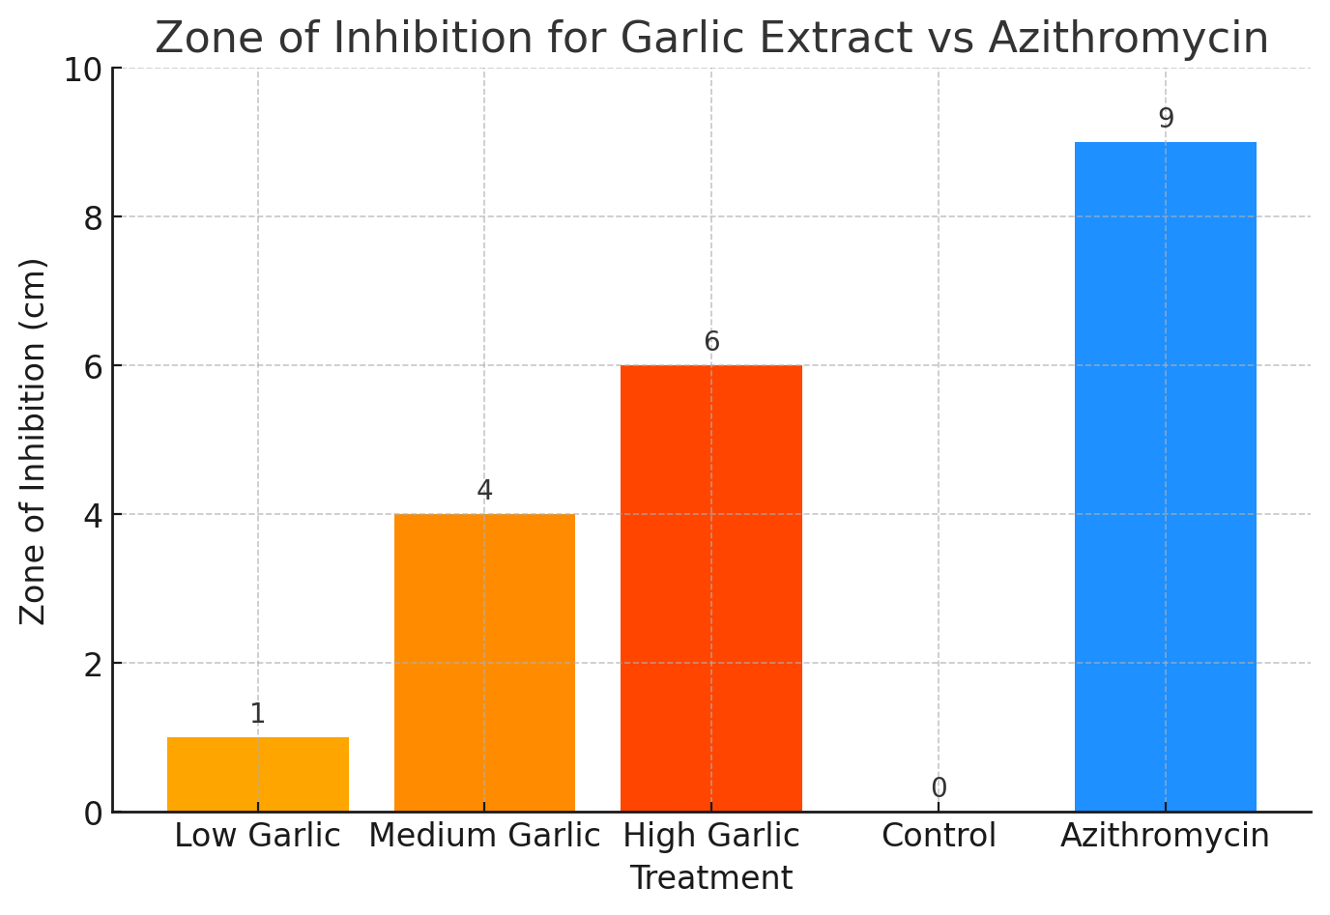
Figure 1: Zones of Inhibition for Garlic Extract and Azithromycin
The results demonstrate a clear concentration-dependent antibacterial effect of garlic extract. The low concentration produced a small inhibition zone of 1 cm, while medium and high concentrations produced progressively larger zones of 4 cm and 6 cm respectively. The control plate showed no inhibition, confirming that bacterial growth was unaffected in the absence of garlic or antibiotic. Azithromycin produced the largest zone of inhibition at 9 cm, indicating stronger antibacterial potency compared to garlic extract. These findings suggest that while garlic exhibits measurable antibacterial properties, its effectiveness is lower than that of a broad-spectrum antibiotic.

Discussion
The results of this study demonstrate that garlic extract exhibits antibacterial activity in a concentration-dependent manner. As the concentration of garlic increased from low to high, the zone of inhibition expanded from 1 cm to 6 cm. This trend indicates that higher concentrations of bioactive compounds in garlic, such as allicin, are more effective at disrupting bacterial growth. The control plate showed no inhibition, confirming that bacterial growth was not affected in the absence of garlic or antibiotic, and validating the experimental setup.
Comparing garlic extract with azithromycin, the antibiotic produced the largest inhibition zone at 9 cm, indicating significantly stronger antibacterial potency. This is expected, as according to Firth et.al [2] azithromycin is a broad-spectrum antibiotic specifically designed to inhibit bacterial growth efficiently. In contrast, garlic acts as a natural antimicrobial agent, which may be effective against some bacteria but is not as potent as pharmaceutical antibiotics.
These findings are consistent with the research of Ankri et.al [3], demonstrating that garlic possesses antibacterial properties due to compounds like allicin, which can interfere with bacterial cell wall synthesis and essential enzymatic processes. However, garlic’s effectiveness varies depending on the concentration and the bacterial strain. In practical terms, garlic could serve as a supplementary natural antimicrobial agent for reducing bacterial contamination on household surfaces, but it cannot effectively replace conventional antibiotics in treating infections.

Limitations and Recommendations
A limitation of this study is that the bacterial species were not identified individually; the results reflect general household bacteria. Future studies could isolate specific bacterial strains to determine the precise effects of garlic extract on each species

Conclusion
Overall, this study confirms that garlic has measurable antibacterial properties and its activity increases with concentration. It is a promising natural supplementary antimicrobial agent that is safe for daily use as Verma et.al [4] showed that garlic has a less inhibitory effect on non-pathogenic bacteria compared to that of pathogenic bacteria. But, it is less effective than standard antibiotics like azithromycin and further research in the matter is encouraged to develop better antibiotics that could potentially target a larger spectrum of bacteria strains without causing any harm to the body.
References

- Sharifi-Rad, J., Rayess, Y., Rizk, A. A., et al. (2015). Fresh Garlic Extract Enhances the Antimicrobial Activities of Antibiotics on Resistant Strains in Vitro. Jundishapur Journal of Microbiology, 8(5), 4–5.
- Firth, A., & Prathapan, P. (2020). Azithromycin: The First Broad-spectrum Therapeutic. European Journal of Medicinal Chemistry, 207, 3-4.
- Ankri, S. (1999). Review: Antimicrobial properties of allicin from garlic. European Journal of Clinical Microbiology & Infectious Diseases, 1(2), 2–3.
- Verma, S., Kaur, S., Singh, J., & Garg, A. (2015). Anti-bacterial effect of garlic (Allium sativum L) extract on different pathogenic and non-pathogenic bacteria. Research Journal of Pharmaceutical, Biological and Chemical Sciences, 6(3), 3–5.

