Design and Implementation of a Scalable Microservice-Based E-Commerce Web Application Using the MERN Stack with Performance Analysis
Ankit
School of Computer Science & Engineering Geeta University Panipat ,India
ankitnehra7000@gmail.com

Amit Jain
School of Computer Science & Engineering Geeta University Panipat ,India
amit_jainci@yahoo.com
Abstract—The demand for e-commerce platforms that can handle a lot of users and work well is getting bigger. This has shown that the old way of building these platforms called architectures is not good enough. It has trouble handling lots of users making changes and keeping the system running.To fix these problems this paper talks about building an e-commerce web application using microservices architecture and the MERN stack. The MERN stack includes MongoDB, Express.js, React.js and Node.js. We broke down the parts of the application such as logging in managing products using the cart processing orders, handling payments and sending notifications into smaller services. Each service has its database so they can work independently and do not affect each other.We also used an API Gateway to manage requests from users route them to the service and keep the system secure. This makes it easier for users to interact with the system and gives us control.To see if our approach works we tested the system with amounts of users and looked at how well it performed. We checked things like how it takes to respond how much work it can handle and how much resources it uses. The results show that while the old monolithic systems work well when there are not users, microservices-based systems are better when there are a lot of users. They can handle users are more flexible and can recover from problems better.This study shows that using microservices with the stack is a good way to build modern e-commerce applications. However it also shows that we need to be careful, with how complex the system's how the services talk to each other and how we deploy them so the system works as well as it can.
Keywords— Microservices Architecture, MERN Stack, E-commerce Application, Scalability, Performance Analysis, API Gateway, Distributed Systems, Web Application Development.
I. INTRODUCTION
The growth of shopping has increased the need for websites that can handle a lot of traffic big sets of data and users who want to interact with them in different ways. Old ways of building websites, where everything is put together in one piece often have trouble keeping up with these needs because they are not very flexible all the parts are connected too closely and it is hard to keep the code up to date.When the system gets more complex these problems get worse. The website does not work as well as it should and it takes longer to make new things.So nowadays people who build software like to use something called microservices architecture, where the website is broken down into pieces that can be worked on and updated one by one which makes it easier to handle and make changes to the website.Digital commerce platforms like these need to be able to handle a lot of traffic and datasets and microservices architecture is a good way to make that happen because digital commerce platforms are all, about being able to handle a lot of users and a lot of data at the same time.
Microservices architecture is really good for making systems more flexible. It does this by breaking down the system into parts, called services that can work independently. Each service does one job and talks to other services using simple methods like RESTful APIs. This makes the system more able to handle changes in workload. What users need. If one service has a problem it does not affect the system as much.
The people who have studied microservices before have found that they make systems more scalable and easier to maintain especially when used in distributed and cloud-based environments [1] [2]. Microservices are also more practical now because of containerization technologies and orchestration platforms. These technologies make it easier to deploy microservices and manage resources across machines. This is why microservices architecture is a choice, for building systems that need to be flexible and able to handle a lot of users.
Microservices have some things going for them but they also make things more complicated. This is especially true when it comes to microservices talking to each other, getting them set up, and how well they work. Some studies have found that when things are not busy, big systems that are all one piece can actually work better because they do not have to spend time talking to other parts [3], [5]. But when things get really busy and a lot of people are using them at the time, microservices can handle it better because they can just add more power as needed [3], [5].This does not happen on its own though. It depends a lot on how the system is designed, how the services are set up, and what the underlying infrastructure is [9]. Also, systems that use microservices often use resources because of the extra work of talking to each other and moving things around [9].So when you are designing applications that need to handle a lot of users, you have to be careful to balance being able to change things with being able to work efficiently [3], [5], [9]. Microservices need to be set up in a way that makes sense for the problem you are trying to solve, and you have to think about how microservices will affect the performance of your application [3], [5], [9].
The MERN stack is really popular for making web applications. It includes MongoDB and Express.js and React.js and Node.js. People like it because it uses JavaScript and you can make things quickly. The MERN stack is great for making full-stack applications.. Most of the time people use it to make simple things or big things that are all connected.There are not studies that look at how the MERN stack works with microservices architecture for big e-commerce applications. Most of the research that's out there does not have a lot of numbers to back it up. It also does not show how things work in the world especially when a lot of people are using it at the same time or when it is used on many computers [6] [8]. The MERN stack is still a choice, for making web applications.
This gap shows that we need to find a way to design and test big applications that use lots of small services like those made with MERN. We need to look at how these applications work when we use many small services together. Now we do not have much information about using MERN to make applications with many small services and also checking how well they work. We need to check things, like how it takes for the application to respond how much work it can do and how many resources it uses. If we do this we can understand how the choices we make when building the application affect how well it works and how big it can get in applications that people use. We need to focus on MERN and microservices to make this happen.
In response to these challenges this research presents the design and implementation of an e-commerce web application using the MERN stack. The proposed system uses a service-oriented architecture. In this architecture core functionalities like authentication, product management, cart operations order processing and payment handling are implemented as services. Each of these services has its database. An API Gateway manages client requests. Routes them to the right services. This ensures that there is one entry point, for clients and the system is well organized. The system is deployed using containerization. This allows for scaling and efficient management of resources. The e-commerce web application and its services are built to scale as needed. This scalable e-commerce web application uses the stack to handle challenges. The MERN stack helps in building an efficient system.
This study takes a look at how the proposed architecture works when it has to handle different amounts of load. We look at things like how long it takes to get a response how much work it can do, how much the computer is being used and how much memory it needs. We do this to see if the system can handle a lot of work and if it is efficient. The study compares what we found out with what other people have discovered. This helps us understand the bad things about using microservices architecture for MERN-based e-commerce applications. We want to give people who build these applications some ideas to think about. We are talking about microservices architecture, for MERN-based e-commerce applications and how it really works.
This work has a main things to offer. First it shows how to design a system for online shopping using the MERN stack. The MERN stack is used to make this system for shopping. Then it explains how to make services that work on their own and have their own databases so the system can handle a lot of users and keep running even if one part breaks. The MERN stack is still used for this system. Lastly it checks how well the system works when it has to handle amounts of users and traffic. The results of this study should help people who make websites and do research make choices about how to design their systems and what technology to use for websites that need to handle a lot of users. The MERN stack and online shopping systems are what this study is about.

II. LITERATURE REVIEW
The way software architecture has changed from systems to microservices has been looked at a lot in recent studies. This is especially true when it comes to making systems bigger, easier to maintain, and able to work with distributed systems. Some important studies show that microservices architecture lets us break down applications into smaller services that work on their own. Each microservice is in charge of a part of the business. This way of doing things makes systems more flexible and allows us to update each service independently, which makes the whole system better at adapting to change [1].Microservices architecture is really good for applications that need to be able to grow and change. When we move from monolithic systems to microservices, we can use resources better and make systems more scalable. This is especially true when we use cloud-based platforms and distributed systems [2]. All of these studies together show that microservices are a way to design modern large-scale applications. Microservices make it easier to maintain and grow systems, which is why many researchers consider microservices the preferred approach for large applications.
A lot of the research looks at how monolithic and microservices architectures compare. When we test them we see that monolithic systems usually work faster and use resources better when they do not have a lot of work to do. This is because the different parts of the system do not have to talk to each other much. On the other hand, microservices architectures work really well when they have to handle a lot of work and many users at the same time. This is because microservices architectures can add power by spreading across many machines [3] [5]. There is a downside to microservices architectures. They are more complicated because the different parts have to talk to each other which can be hard to manage. Also, microservices architectures need equipment to work properly. So we can see that microservices architectures are better in some situations. It depends on what kind of work they have to do and how they are set up. Microservices architectures are not always better than systems. It really depends on the situation and what the microservices architectures are being used for. Microservices architectures have to be used in the way to be helpful.
Microservices are compared to systems in more detail with metrics like how long it takes to respond, how much work can be done, and how much of the computer’s CPU and memory are used [6], [9]. These studies show that microservices are better at handling a lot of work and can keep going even if one part stops working. They use more resources than other systems. This is because they need containers and have to talk to each other over a network, which takes extra time and energy.Other research on using containers, like Docker, to set up systems shows that it can make things more consistent and able to handle work, but it can also make performance vary depending on how the system is set up and how big it is [6]. This means we have to be careful when deciding whether to use microservices because we have to balance being able to handle a lot of work with being efficient. Microservices need to be looked at to see if they are worth using because microservices can be good but also have some problems.
The design and breakdown of microservices architectures are really important for how the system works and how easy it is to maintain. When models for software quality are considered, defining the boundaries for each service is crucial for making sure the services work well together and do not rely too much on each other [4]. If the services are not broken down correctly, it can cause a lot of communication between services, which increases the time it takes for things to happen and makes the whole system more complicated. So microservices architecture is successful when it is designed and put into action effectively, not just when the decision is made to use it [4].
When thinking about microservices systems consider the architecture. Some studies have suggested ways to test how well microservices systems work in controlled environments. To do this they compare how the same application works when it is built using microservices and when it is built using an architecture. This comparison gives us information, about how the system behaves when it has to handle different amounts of work.These studies show that microservices work well in environments that are distributed and based in the cloud. This is because microservices can be easily scaled up to handle demand [7] [8]. However these studies also have some limitations. For example the experimental setups are often too simple. They do not accurately reflect the patterns of traffic that we see in the real world. Additionally they do not fully consider how all the different parts of the system work together. This means that we cannot automatically assume that the findings of these studies will apply to all microservices systems.
There is a lot of research there but we still have a big problem to solve when it comes to using microservices architecture with the MERN stack and other modern full-stack technologies. Most of the time people are just comparing architectures or looking at how they work in one specific programming environment. They are not really thinking about what makes JavaScript-based full-stack development special. We also need research that looks at how things work in real life and checks to see how well they perform, especially when it comes to big e-commerce applications that need to be able to handle a lot of traffic. A lot of the research that's out there does not include important parts, like API Gateways, databases that are managed separately for each service and deploying the whole system using the latest development stacks. The MERN stack is really important here. We need to think about how microservices architecture works with the MERN stack.
The gap shows that we need to look at the picture and combine microservices architecture with modern development frameworks. We also need to check how well it works in life. Specifically we do not know much about how MERN-based microservices systems work when it comes to handling a lot of users responding quickly and using resources wisely when they are used for e-commerce platforms. It is very important to understand this so we can make decisions, about how to design real world applications. MERN-based microservices systems are what we need to focus on to see how they really work.
The current study is trying to solve some issues. It is trying to build an e-commerce web application using the stack. This MERN stack application will have parts that work on their own an API Gateway and different databases for each part. The main goal of this study is to use what we learn about architecture in school and apply it to building something. We want to see how the things we learn in theory actually work when we build the stack application. The study will also take a look at how well the MERN stack application works by looking at numbers and metrics. This will help us understand how microservices work with the stack and microservices architecture when we build web applications, with the MERN stack and microservices architecture.

III. PROPOSED SYSTEM ARCHITECTURE AND METHODOLOGY
This study is about a way to build an e-commerce website using the MERN stack. It uses something called microservices. This means the website is made up of independent parts that work together. Each part can be. Scaled on its own without affecting the rest of the website.The system is designed to fix the problems of style websites that are, like one big block. This new way is better because it uses resources efficiently and if one part of the website has a problem it does not bring down the whole website. The MERN stack is used to build this e-commerce website with microservices. This way of building websites follows some established guidelines [1] [4].

A. System Architecture Overview
The new system is made up of small parts that work together. These parts are called microservices. Each microservice does a job for the business. This way of building the system is good because it lets us work on each part separately. We can also put each part into use on its own. Make it bigger or smaller as needed. Lots of people think that microservices are an idea because they make it easier to develop and scale the system. The microservices system has advantages, such, as modular development and flexible scalability, which are benefits of using microservices [1], [4].
Each service works on its own so if something goes wrong it does not affect the services. This is different from the way of doing things, where everything is connected (monolithic) and a problem in one area can cause problems everywhere. The new way means that if one service has a problem it will not cause problems, for the system. This makes the system stronger and easier to take care of [2].
The frontend layer is developed using React and interacts with backend services exclusively through an API Gateway. This abstraction layer simplifies client communication and provides a centralized mechanism for request handling and system control.

B. API Gateway and Communication Model
The API Gateway is where all client requests go to. It handles a things like routing and making sure people are who they say they are. The API Gateway also sends requests to where they need to go. This makes things easier, for the client. Helps keep the whole system organized. The API Gateway also helps keep everything secure and makes it easier to monitor what is going on with the API Gateway and the system.
The system uses APIs to talk to different services. This way is chosen because it is simple and works with other systems, especially the MERN ecosystem [1] that uses JavaScript. Even though REST can slow things down a bit compared to talking within the process it is still a good choice for systems that are spread out when we use smart routing and keep the amount of data small. The system uses APIs for communication, between services because it is a simple and practical way to do things.
Standardized API contracts are defined to make sure that all services communicate with each other in a way.This practice helps to reduce coupling between services.It also allows services to change and improve on their own without affecting parts of the system.This is really important, for building systems that can grow and handle load [4].

C. Service Decomposition and Functional Design
The system is divided into multiple microservices, each adhering to the single-responsibility principle to maintain clear functional boundaries.
- The authentication service manages user identity, registration, and authorization using token-based mechanisms.
- The product service handles product catalog operations, including creation, updates, and retrieval.
- The cart service maintains user-specific cart data and supports dynamic updates.
- The order service processes transactions and coordinates order workflows.
- The payment service is responsible for secure transaction handling and payment integration.
- The notification service manages asynchronous communication such as order confirmations.
This decomposition ensures that each service remains focused and independently scalable. Proper service granularity is carefully maintained to avoid excessive fragmentation or unintended coupling, both of which can negatively impact system performance and maintainability [4].

D. Data Management and Persistence Strategy
The proposed architecture uses a database for each service so each small part of the system has its database with MongoDB. This way each small part of the system does not have to share data with parts and it can work on its own. The database-per-service pattern makes the system better because it can handle work and it is less likely to fail. The database-, per-service pattern improves the scalability of the system and the fault tolerance of the system[2].
The thing about distributed transactions is that they can really slow things down and make the system less efficient. So the design does not use coupled transactional mechanisms. The system uses an approach called consistency. This means that the system manages data synchronization across services, at the application level. This is what people usually do when they design distributed systems. It helps the system work well when a lot of things are happening at the same time. Distributed transactions are not used because they can introduce overhead. Instead the system uses consistency to support high scalability under concurrent workloads [3].

E. Containerization and Deployment Strategy
Docker is used to make sure all services work the way in different environments. This is done by putting each service and the things it needs into a container. This way Docker makes it easy to move services around. It reduces problems that happen because of the environment. Docker services are, like packages that have everything they need so they can work properly anywhere.
The system is made to help with scaling. This means you can use instances of services to deal with more traffic. The way the containers are managed lets you scale up or down based on how busy the system's. This is really important for shopping applications that get a lot of traffic. Some studies have shown that using containers, with microservices makes the system more scalable and helps use resources when there are a lot of different tasks to handle [7] [8].
Docker Compose use to manage all the containers. This way our system can still work with big systems that help us make it bigger and stronger when we are ready to use it for real.

F. Security and Middleware Integration
Security is something that we take seriously. The system has layers to keep everything safe. The API Gateway is, like a gatekeeper that checks if you are who you say you are. It uses something called JSON Web Tokens or JWT for short to make sure that only people who are allowed can get to the backend services. This way we do not have to repeat the security checks over and over again. The API Gateway does it all for us, which makes it a lot easier to manage who can access what. The Security system and the API Gateway and JSON Web Tokens all work together to keep the Security of the system strong..

G. Performance Evaluation Framework
To assess the effectiveness of the proposed architecture, a structured performance evaluation framework is established. The system is tested under varying load conditions to analyze its behavior in both low-traffic and high-traffic scenarios.
Key performance metrics include:
- Response time
- Throughput (requests per second)
- CPU utilization
- Memory consumption
- System scalability under concurrent users
Load testing is done using tools, like Apache JMeter. These tools help simulate real-world traffic.We run the test times to get consistent and reliable results. This is because performance can vary a lot in microservice-based environments [3] [9].
Prior research shows that microservices can cause work when things are slow because they have to talk to each other.. When things get really busy microservices are actually better at handling the load because they can process things in different places [5],[8] and add more power as needed. The evaluation we are proposing is going to check if this is true, for a MERN-based e-commerce website.

H. Contribution and Research Gap Alignment
The new system is going to fix some problems that people have found in other research. A lot of studies give us ideas. Compare things in a controlled way but there is not much research that looks at how things work in the real world. See the MERN stack and microservices work together in an application and how well they perform. The MERN stack is a part of this and we want to know how it works with microservices. Then make analysis of how well the MERN stack and microservices perform together.
This work contributes by:
- Designing a complete microservices-based e-commerce architecture using MERN
- Implementing a practical, modular, and scalable system
- Conducting systematic performance evaluation under realistic workloads
- Bridging the gap between conceptual research and real-world application deployment

IV. IMPLEMENTATION DETAILS
The proposed system is implemented as a distributed microservices-based e-commerce platform using the MERN stack, with a clear separation of concerns across independent services. Each service is designed, developed, and deployed as an autonomous unit, enabling modular development, scalability, and independent lifecycle management, as emphasized in microservices-based system design principles [1], [4].

A. Service Implementation Strategy
Each microservice is made using Node.js and Express.js. It follows a structure that has different parts, like controllers and services and models and routes. This helps to keep each part separate so the whole thing is easy to maintain. The different services talk to each other using APIs. This is a way for them to communicate with each other in a system that has many parts[1]. Node.js and Express.js help make this work. RESTful APIs are a choice because they are easy to use and many people use them already.
The authentication service takes care of user registration, login and authorization using JSON Web Tokens. It checks user sessions to make sure they are valid and keeps protected routes. The product service is in charge of managing the catalog, which includes creating products getting products and updating products. The cart service and the order service do the thing for user transactions making sure everything is consistent, within each service.
To keep services each microservice connects to its own database.This approach spreads out data management. Cuts down on dependencies, between services.It also matches what experts recommend for building microservice architectures [4] that can grow and handle load.This way each microservice manages its database instance.It helps to keep the microservices from getting tangled up with each other.

B. API Gateway Integration
An API Gateway is like a door for all requests from clients. It sends these requests to the right backend services. This makes it easier for clients to interact with our system and hides how complicated the internal services are.
The gateway also checks if the requests are valid, before sending them to the services. This way we do not have to check each request times and we can make sure everything is secure. Using an API Gateway is what people usually do when they have small services working together it helps handle requests better and keeps the system organized [2].

C. Frontend Implementation
The React.js frontend is made to be easy to use on devices and it looks really good. We use parts that can be used again to make the frontend work well and to keep everything organized. The React.js application talks, to the backend services using something called Axios to make sure everything works together seamlessly through the API Gateway. The React.js frontend really needs the API Gateway to help it talk to the backend services.
State management is handled with the React Context API. This API keeps track of authentication details and user session data throughout the application. Do protected routes to limit access, to authenticated users. This makes the application more secure. Improves the user experience.The React Context API plays a role in managing the authentication state and user session data.

D. Containerization and Deployment
Having Docker to put all our services in containers. This means that everything works the way in different places. Each small part of our system or microservice gets its container. This helps keep everything and makes it easier to get things set up and running. We have microservices. These microservices run in their own containers, which is really helpful..
Docker Compose helps to manage services at once. It lets containers start up and talk to each other at the time.This makes it easier to set up and deploy applications [3],[7]Using Docker Compose is good, for DevOps because it helps with deploying distributed applications.It is used a lot with tools.Docker Compose works with many services.

E. Inter-Service Communication
Communication between services happens through REST APIs over HTTP. This method does add some work compared to systems that are all in one [3], [9]. It makes it easier to make changes and allows each service to be scaled on its own. Past research shows that a bit of communication time is okay for better scalability and modularity in systems that are spread out [3], [9].

F. Performance Testing Implementation
To see how well a system works we do something called load testing. Use tools like Apache JMeter to do this. The system is put under amounts of work to measure things like how long it takes to respond how much work it can handle, how much the computer is being used and how much memory it needs.
The testing process involves simulating concurrent users accessing different services simultaneously through the API Gateway. This approach reflects real-world usage scenarios and enables evaluation of system behavior under stress conditions.
The collected metrics are analyzed to compare system performance characteristics with findings from existing studies. Prior research indicates that microservices may introduce additional overhead under low workloads but demonstrate superior scalability and efficiency under high traffic conditions [5], [8], [9].

G. Logging and Monitoring
A logging system is set up to keep track of how services working. It uses shared tools to log things like requests, errors and how services talk to each other. This helps with finding problems and understanding how well the system is performing.
Add monitoring tools to keep an eye on the systems health and how much resources its using. This can be done with cloud tools or special tools for containers. Monitoring is really important, in systems because there are many services interacting with each other in different environments [6].

V. RESULTS AND PERFORMANCE EVALUATION
The performance of the proposed microservices-based e-commerce system is looked, at closely through testing how it handles a lot of work and checking system metrics. The main goal of this evaluation is to see how well the microservices-based e-commerce system can handle a lot of users and work how fast it. How well it uses its resources when it has a lot of work to do. This is done to compare the behavior of the microservices-based e-commerce system with what other people have found out about microservices.

A. Experimental Setup
The system uses containers to run its services.Each service works on its own within a Docker setup..The Docker environment helps services work independently.Docker Compose is used for controlled execution and communication between services.The system relies on Docker and Docker Compose
Performance testing is done using Apache JMeter. It simulates users making requests to the system at the same time through the API Gateway.We design test scenarios to mimic how real users behave.These scenarios include: browsing products, adding items to the cart, placing orders, with Apache JMeter and API Gateway.
The evaluation focuses on the following performance metrics:
- Response Time
- Throughput (requests per second)
- CPU Utilization
- Memory Usage
These metrics are widely used in existing studies for evaluating distributed systems and microservices architectures [3], [8].

B. Test Scenarios
To ensure comprehensive evaluation, the system is tested under three different workload conditions:
- Low Load Scenario
A small number of concurrent users (e.g., 10–50 users) interact with the system.
- Moderate Load Scenario
Medium concurrent users (e.g., 100–200 users) simulate realistic traffic conditions.
- High Load Scenario
A large number of concurrent users (e.g., 500+ users) test the scalability limits of the system.
These scenarios allow observation of system behavior across different operational conditions, similar to benchmarking approaches used in prior research [5], [9].

C. Performance Results

1. Response Time Analysis
The proposed microservices-based e-commerce system works well when it is not busy. It can handle requests quickly because the different parts of the system can talk to each other easily.When more people start using the system at the time it takes a little longer to respond. This is because the different parts of the system have to communicate with each more.When a lot of people are using the system it still works pretty well. The microservices-based e-commerce system can handle a lot of work because it can spread the work across different parts.Look at Fig 1, you can see that the microservices-based e-commerce system gets a little slower when a lot of people are using it.. It stays stable and does not get too slow.The old kind of system called a system gets much slower when a lot of people are using it. This means it is not very good, at handling a lot of work at the time and it is hard to make it work better by just adding more power [3] [5].

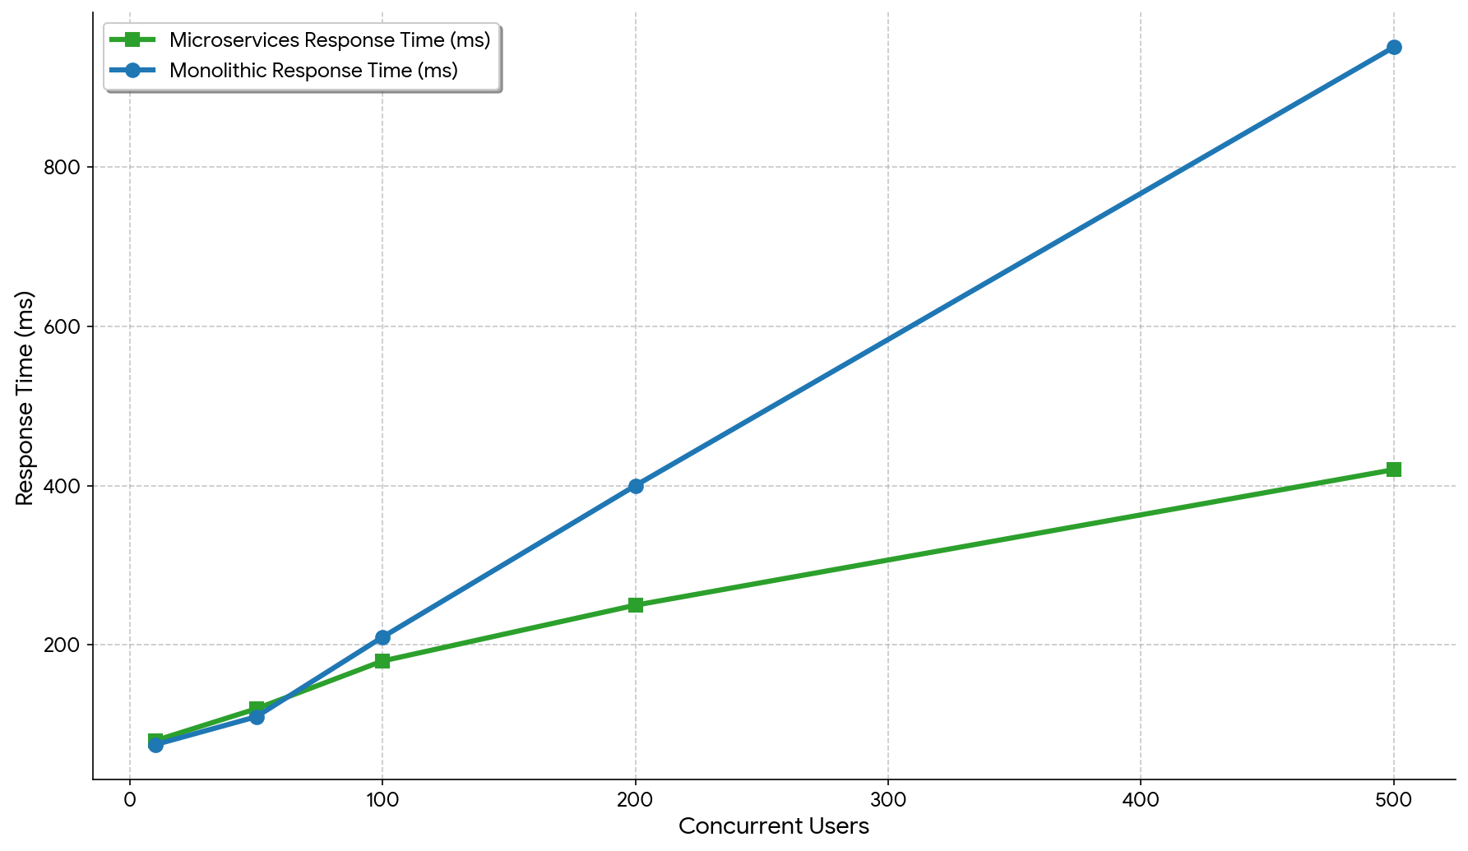
Fig. 1. Response Time of Microservices vs Monolithic System under Varying Concurrent Users.
The figure illustrates the average response time of the proposed microservices-based e-commerce system compared to a monolithic architecture across different levels of concurrent users, highlighting the stability and scalability of the microservices approach.

2. Throughput Evaluation
The system can handle requests per second when there are more users. This is because the system can process requests at the time when there are a lot of users. The system can handle requests when there are a lot of users and the system is working hard.As See in Fig. 2 The system made up of services can handle a lot more requests than a big system (monolithic) that does everything by itself. This is especially true when the system is working hard.The small services system is good, at handling a lot of requests at the time. This shows that a system made up of parts can handle requests better when it needs to be big [8].
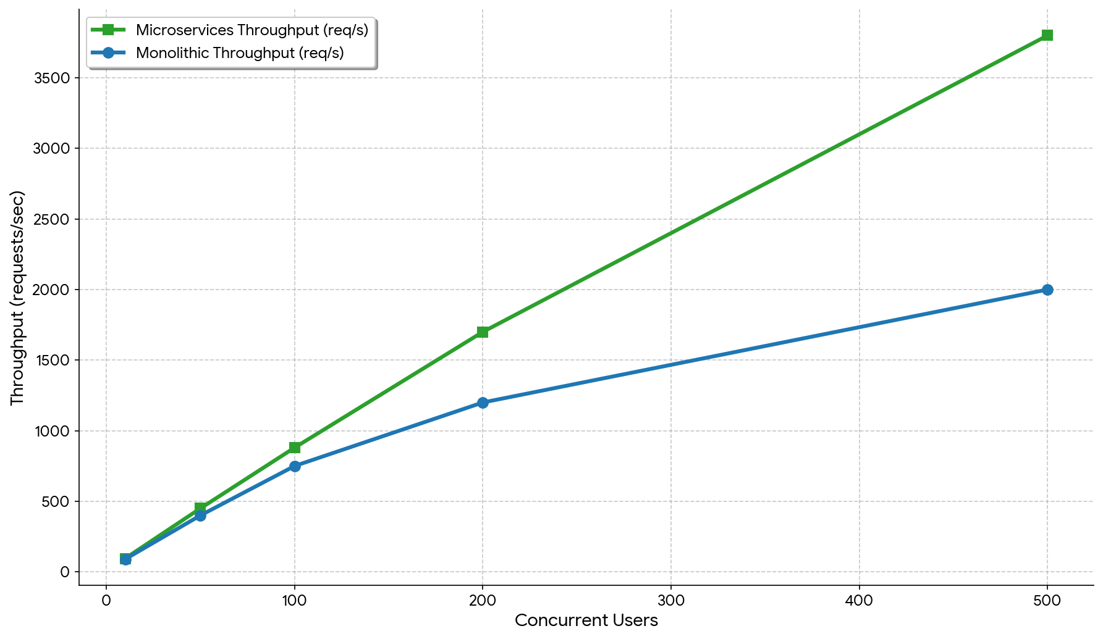
Fig. 2. Throughput of Microservices vs Monolithic System under Varying Concurrent Users.
The figure illustrates the throughput comparison between microservices and monolithic architectures under increasing concurrent user loads, highlighting the superior scalability and parallel processing capability of the microservices-based system.

3. Resource Utilization
When the microservices-based e-commerce system is really busy it uses the CPU and the memory. This is because each part of the microservices-based e-commerce system works on its own and uses its resources. So the whole microservices-based e-commerce system uses a bit CPU and memory than a regular system (monolithic).The microservices-based e-commerce system is better because if one part of the microservices-based e-commerce system has problems it does not affect the parts of the microservices-based e-commerce system. The microservices-based e-commerce system can also handle users easily.As seen in Fig 3 and Figure 4 when more users are on the microservices-based e-commerce system the CPU usage goes up slowly. The memory usage also increases in a way.These figures show that even though the microservices-based e-commerce system uses resources overall it stays stable and works well when a lot of people are using the microservices-based e-commerce system which is not always the case with regular systems (monolithic) that can get slow when a lot of people are on them at the same time.The microservices-based e-commerce system is better, at handling traffic [9] .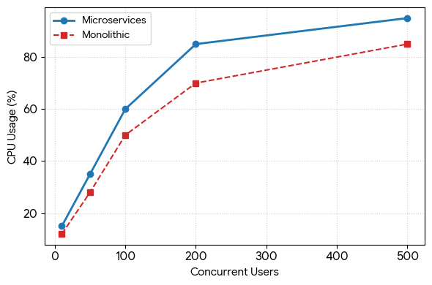Fig. 3. CPU Utilization of Microservices vs Monolithic System under Varying Concurrent Users.
The figure illustrates CPU usage trends across different levels of concurrent users, highlighting distributed resource consumption and improved scalability of microservices.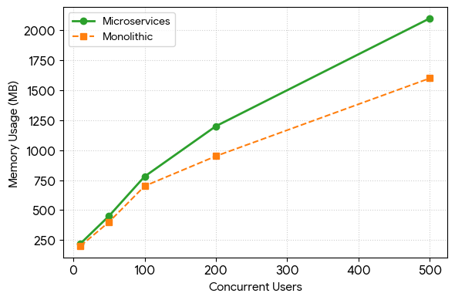Fig. 4. Memory Utilization of Microservices vs Monolithic System under Varying Concurrent Users.
The figure shows memory usage trends under varying loads, emphasizing that microservices allocate memory independently for each service, ensuring stability and fault tolerance under high concurrency.

4. Scalability Analysis
The system can handle users at a time by using multiple machines to do the work.This way the system does not get overwhelmed.Each part of the system can be scaled up or down without affecting parts.So the system does not have the problems that large all-in-one systems have.The results show that systems made up of services work well when many people use them.This confirms what other studies have found, such as the ones, in [5]. [8].

D. Comparative Discussion
The results of the experiment show that there is a difference between monolithic and microservices architectures. Monolithic systems are good when it comes to speed because they do not have to communicate much. This means they can respond quickly when there are not people using them. However monolithic systems have a time handling a lot of users at the same time.
In contrast the microservices system we are talking about takes a little longer to respond because it has to communicate more.. It is very good, at handling a lot of users and it is also very flexible and reliable. This is what other studies have found too. They say that microservices architectures are the way to go for complicated applications [3] [7].

E. Key Observations
The following observations can be derived from the performance evaluation:
- Microservices architecture maintains stable performance under high concurrent workloads
- Response time increases with load but remains within acceptable limits
- Throughput improves significantly due to parallel processing
- Resource consumption is higher but distributed across services
- The system demonstrates strong horizontal scalability
These observations validate the effectiveness of the proposed architecture for building scalable e-commerce platforms.

F. Summary of Findings
The performance evaluation confirms that the implemented system successfully achieves the primary objective of scalability while maintaining acceptable performance levels. Although the architecture introduces some overhead due to inter-service communication, the benefits in terms of scalability and modularity outweigh these limitations.
The results are consistent with existing literature, reinforcing the suitability of microservices architecture for modern web applications requiring high scalability and flexibility [3], [8], [9].
VI. CONCLUSION
This study is about creating an online shopping website using the MERN stack. The MERN stack is used to make a website that can handle a lot of users and work well even when it is very busy.The old way of building websites is not good for websites with many users. So we made this website with many small parts that work together.These small parts do things like help users log in manage products handle shopping carts, process orders and take payments.This makes the website better because each part can work on its own. If one part has a problem it does not affect the parts.Use API Gateway which help the different parts of the website talk to each other and, to users. This makes it easier for users to use the website and helps the website handle a lot of users at the time.
The way they did things showed that using a database for each service and putting everything in Docker containers made a difference. This made it a lot easier to get everything set up right every time. It also made it possible to add power when it was needed. Each service worked on its own, which meant that people could work on set up and make each service bigger without affecting the services and that is really important, for applications that have to handle a lot of users.
The performance analysis gave us a lot of information about how the system works when it has to handle amounts of work. when the system is not very busy the microservices make it work a bit harder to talk to each other.. When the system gets busier it can actually handle a lot more work use its resources better and scale up really well. Looked at things, like how it takes for the system to respond how much work it can handle and what resources it uses and all of these things showed us that spreading the work across the microservices is a good idea. The microservices performance was better because the system can handle work when it is busy. The system and the microservices work well together to make this happen..
The study also found some problems. These problems include systems that're too complicated services that have trouble talking to each other and needing more equipment and space. These problems show that we need to design services in a way figure out better ways for them to communicate and make sure we are using our resources correctly. The study really highlights the importance of service design and proper resource management, for services. Services need to be designed in a way that makes sense and resources need to be managed for services to work well..
So the MERN stack and microservices architecture work really well together for building modern e-commerce applications. This system is good because it takes ideas about architecture and actually makes them work in life. It also looks at how the system performs..
VII. REFERENCES
[1] T. Hunter II wrote a book called *Developing Microservices with Node.js*. It was published in Birmingham, UK by Packt Publishing in 2017.[Online]. Available:http://www.digitalbreakdown.net/sandbox/Ebooks/Developing-Microservices-with-Node.js.pdf
[2] M. Zaymus did a thesis on Decomposition of Monolithic Web Application to Microservices for his M.Sc. At Jyväskylä University of Applied Sciences in Finland in 2017. The thesis is [Online]. Available: https://www.theseus.fi/bitstream/handle/10024/131110/Zaymus_thesis.pdf
[3] N. Bjørndal and some other people did a study on Migration from Monolith to Microservices. They even did a case study. [Online]. Available: On ResearchGate in 2020 at https://www.researchgate.net/publication/339749917_Migration_from_Monolith_to_Microservices_Benchmarking_a_Case_Study
[4] M. L. Salunkhe did a Master’s thesis on From Monolithic Applications to Microservices. The thesis is about guidance on refactoring techniques and result evaluation. [Online]. Available: On ResearchGate in 2018 at https://www.researchgate.net/publication/326462288_From_Monolithic_Applications_to_Microservices_Guidance_on_Refactoring_Techniques_and_Result_Evaluation_Master_Thesis
[5] There was a conference called SQAMIA 2025 where they talked about Performance Comparison between a Monolithic and a Microservice Application. It was held in Maribor, Slovenia in October 2025. [Online]. Available: https://www.researchgate.net/publication/396984026_Performance_Comparison_between_a_Monolithic_and_a_Microservice_Application
[6] M. K. G. P. Varela and A. Bucchiarone did a study on Monolithic vs. Microservice Architecture. They looked at the performance and scalability of microservices. [Online]. Available: the study in *IEEE Access* volume 10 in 2022 at https://ieeexplore.ieee.org/document/9717259
[7] F. Tapia and some other people did a study on the performance of Monolithic Systems and Microservices. You can find the study in *Applied Sciences* volume 10 in 2020 at https://www.mdpi.com/2076-3417/10/17/5797
[8] Y. Sun did a thesis on the performance of Microservice Architectures. The thesis is about application performance and resource consumption. [Online] Available: at https://helda.helsinki.fi/server/api/core/bitstreams/041f0804-b940-43be-9e01-be856a06084a/content
[9] A. Barczak and M. Barczak did a study on the performance of Monolith and Microservices-Based Applications. They presented their findings at a conference, in 2021. [Online]. Available: https://www.iiis.org/CDs2021/CD2021Summer/papers/SA354XK.pdf

